Enswitch Administrator Guide
Enswitch Release 3.10

June 2013

Contents
Changes in This Release 5
1 Introduction 6
1.1 The Purpose of this Document 6
1.2 Features 6
1.3 Workflows 6
2 User Enrollment 7
3 User Switch 10
4 Reports 11
4.1 Report Types 11
4.2 View Reports 12
5 Alerts 13
6 Bulk Dialer 15
7 Call Recording 17
7.1 Call Recording Groups 17
7.2 Record Inbox 18
7.3 Record Groups and Numbers Association 19
8 Classes of Service 21
8.1 Add Class of Service 21
8.2 Class of Service Exceptions 22
9 Conferences 24
10 Destination Features 27
10.1 Location of the Destination Feature Setting 27
10.2 Selecting a Destination Feature 27
11 Dial by Name 31
11.1 System Rules for Matching Names 31
11.2 Dial By Name Configuration 32
12 Feature Codes 34
12.1 Default Feature Codes 34
12.2 Add Feature Codes 34
12.3 Export Feature Codes 37
12.4 Import Feature Codes 37
13 Feature Prefixes 38
13.1 Purposes of Feature Prefix 38
13.2 Add Feature Prefix 39
14 Hunt Groups 41
14.1 Types of Hunt Groups 41
14.2 Add Hunt Groups 42
15 IVR Menus 45
15.1 Add New IVR Menu 45
16 Mailboxes 48
16.1 Add New and Modify Mailboxes 48
16.2 Mailbox Statistics 50
17 Music 51
18 Numbers 53
18.1 Add New Telephone Numbers 53
18.2 Number Routing 55
19 Pattern Menus 57
19.1 New Pattern Menus 57
19.2 Add New Pattern 58
19.3 Export Patterns 59
19.4 Import Patterns 59
20 People 60
20.1 Add New Person 60
20.2 Switch Person 62
21 Page Groups 63
21.1 New Page Groups 63
21.2 Page Group Destinations 64
22 Pickup Groups 65
23 Provisioning 66
23.1 New Provisioning Template 66
23.2 Copy a Template 67
24 Queues 68
24.1 Adding a Queue 68
24.2 Adding Destinations to a Queue 70
24.3 Add a Mechanism to Log In and Out of Queues 71
25 Remote Access 72
26 Sound Files 75
26.1 Create or Modify Sound Files 75
26.2 Call to Record 76
27 Speed Dials 77
27.1 Create a Shared Speed Dial 77
27.2 Export Speed Dials 78
27.3 Import Speed Dials 78
28 Telephone Lines 79
28.1 Add a New Telephone Line 79
28.2 View Call History 84
28.3 Set the Emergency Address 85
28.4 Display Missed Calls 86
29 Times and Dates 87
29.1 Create a New Time Group 87
29.2 Add a Time Period 89
30 Virtual Telephones 90
31 Web URLs 91
31.1 Call Flow 91
31.2 Fields 91
31.3 Create and Modify Web URL 93
32 Workflows 95
32.1 Allowing Numbers to be Toggled Separately 95
32.1.1 Overview 95
32.1.2 Associate the Number Menu Feature with a Code 95
32.1.3 Toggle the Destination of a Phone Line Using the Code 96
32.2 Allowing Users to Toggle the Routing of Numbers Using Their Handsets 96
32.2.1 Overview 96
32.2.2 Associate the Set Numbers Routing: Weekends Feature With a Code 97
32.2.3 Add a Time Route to All Numbers to be Routed with this Feature 97
32.2.4 Associate the Set Numbers Routing: Normal Feature with a Code 98
32.2.5 Use the Codes to Change the Routing of the Selected Phone Lines 98
32.3 Connecting an Incoming Call to a Queue via Tiered IVR Menus 99
32.3.1 Overview 99
32.3.2 Create and Configure a Queue 99
32.3.3 Create and Configure a Secondary IVR Menu 101
32.3.4 Create and Configure a Primary IVR Menu 101
32.3.5 Select a Phone Number and Connect It to the Primary IVR Menu 102
32.4 Connecting an Incoming Call to a Hunt Group that Terminates in a Mailbox via Tiered IVR Menus 103
32.4.1 Overview 103
32.4.2 Define and Configure the Destination Mailbox 103
32.4.3 Create and Configure a Hunt Group 104
32.4.4 Create a Tiered IVR 105
32.4.5 Direct a Secondary IVR Option to the Hunt Group 105
32.4.6 Select a Phone Number and Direct it to the Primary IVR Menu 105
32.5 Connecting an Incoming Call to a Telephone Line, Then to a Hunt Group That Terminates in a Mailbox 106
32.5.1 Overview 106
32.5.2 Define and Configure the Destination Mailbox 106
32.5.3 Create and Configure a Hunt Group 106
32.5.4 Direct an Incoming Telephone Line to the Hunt Group 106
32.6 Enswitch per-Telephone Provision Setting 107
32.6.1 Overview 107
32.6.2 Configure the Telephone with Handset Information 108
32.6.3 Configure the Handset with the Enswitch URL 108
32.7 Integrating with Queue Statistics 108
32.7.1 Overview 108
32.7.2 Configure Queue Statistics 109
32.7.3 Export Queue Statistics 109
32.8 RDNIS Voicemail Configuration 110
32.8.1 Overview 110
32.8.2 Create a Mailbox for an RDNIS-Formatted Forwarded Call 110
32.8.3 Assign a Number that Connects All Calls to Voicemail 111
32.9 Creating a Hosted Recording Service 111
32.9.1 Overview 111
32.9.2 Adding a New Group 111
32.9.3 Setting Recording Parameters 112
32.9.4 Associate the Record Group with a Telephone Line 113
32.9.5 Reviewing Recordings 114
A. Telephone Models 116

Changes in This Release
The changes incorporated in Enswitch Release 3.10 reflected in this document include:
# | Change | See section
1 | The “Screen calls” field was added to the “New Destination” page in the “Add Hunt Groups” section. | 14.2

Introduction

The Purpose of this Document
The Enswitch administrator uses the web interface of Enswitch to manage the system. The administrator needs to know the needs of the customers – the end-users of Enswitch – and keep all data in the system correct and up to date. The following sections describe the Enswitch web interface features and also detail some useful workflows that use multiple features to accomplish a task.

Features
The Enswitch features manage all of the elements of the system. They establish the connections between telephone line phone numbers, users, and all of the other system features. Each feature description shows how to add elements and update them and, where the feature supports it, export and import information from and to the system.

Workflows
Each workflow shows how to perform a task or a particular type of setting that, in most cases, requires working with more than one web interface feature. The flows provide a recommended order of operations. They demonstrate by example, but do not attempt to duplicate the information in the individual feature descriptions.
- Allowing Numbers to be Toggled Separately
- Allowing Users to Toggle the Routing of Numbers Using Their Handsets
- Connecting an Incoming Call to a Queue via Tiered IVR Menus
- Connecting an Incoming Call to a Hunt Group that Terminates in a Mailbox via Tiered IVR Menus
- Connecting an Incoming Call to a Telephone Line, Then to a Hunt Group That Terminates in a Mailbox
- Enswitch per-Telephone Provision Setting
- Integrating with Queue Statistics
- RDNIS Voicemail Configuration
- Creating a Hosted Recording Service

User Enrollment
You can add features for a single user or for a number of users quickly in either of two ways:
- For a small number of users
- For many users
To add a small number of users:
        - Log in to the Enswitch web interface.
          - Go to Features » Add user to display the New user form.
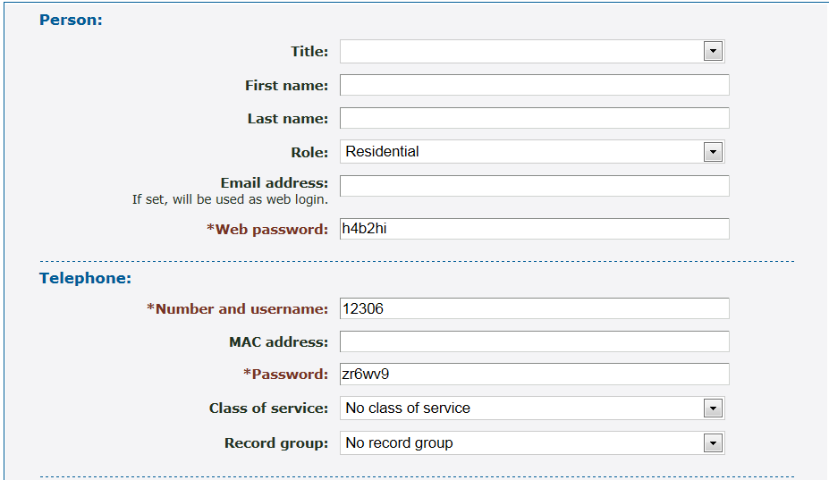
          - Enter the following: (fields marked with are required):
            - Title: The user’s title.
            - First name: The user’s first name.
            - Last name: The user’s last name.
            - Role.
            - Email address: The user’s email address: If an email address is provided, this will be the user’s login ID to gain access to the system web interface.
- Web password.
- Number and username: User’s telephone number and username.
            - MAC address: MAC address of the user’s phone.
- Password.
            - Class of service.
            - Record group.
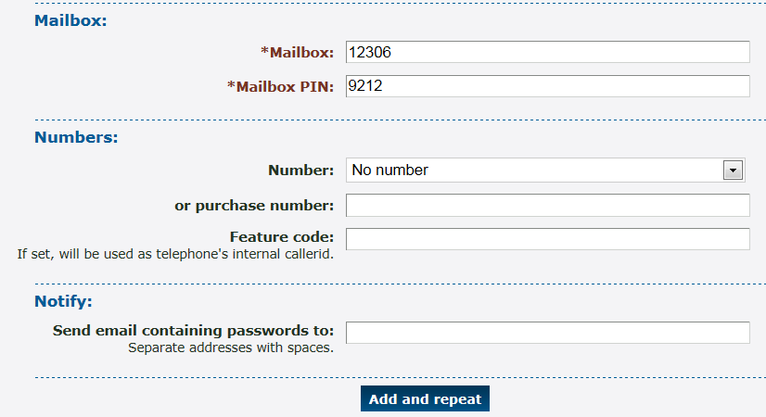
- Mailbox: Voice mailbox number (usually the same as the phone number).
- Mailbox PIN.
            - Number: An incoming line associated with this user.
            - or purchase number: An alternative to the Number option – purchase a number for this user.
            - Feature code.
            - Send email containing passwords to: One or more email address separated by spaces. This is the email address that will receive the passwords created for this user. If an email is not provided, the passwords need to be copied and saved external to the system.
          - Click Add and repeat. The system saves the settings and displays the form so that you can add another user.
To add many users:
        - Create a .csv file with the following format and fields:
"<title>","<first name>","<last name>","<role>","<email>","<web username>","<web password>","<telephone line>","<telephone MAC address>","<telephone password>","<class of service>","<record group>","<use hunt group>","<mailbox>","<mailbox PIN>","<number>","<location callerid>","<feature code>","<mailbox feature code>","<page group feature code>"
For example:
“Mr.”,”John”,Doe”,”User”,”jdoe@example.com”,”jdoe”,”webpass”,”12345”,,”phonepass”,,,,”12345”,”1234”,,,,,
          - Log in to the Enswitch web interface.
          - Go to Features » Add user.
          - Click Import.
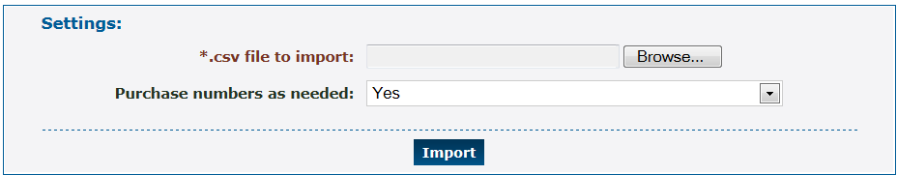
          - Select the following:
- The path to the .csv on your local machine.
            - Whether or not to purchase numbers as needed. If you select no and do not already have the necessary numbers for the number of users in the file, the import fails.
          - Click Import. The system processes the .csv file a line at a time, creating a user for each line.

User Switch
It is sometimes useful to log in as a different user to help solve problems. If you know the user’s password, you can log out and then log in as that user. In most cases, however, you will not know the password, nor is it good practice to. Use the following procedure to log in as another person if you do not know the password.
To switch users:
        - Log in to the Enswitch web interface.
          - Go to Features » People.
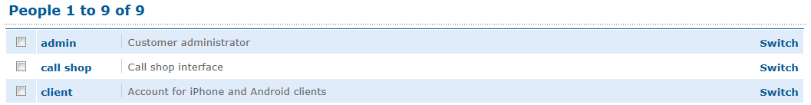
          - Click Switch beside the person to whom you wish to switch.
          - Do whatever actions you wish to perform as this person.
          - When you are done, return to Features » People and switch to your normal login (for example, admin). Alternatively, you can log out using the select box at the top-right of the page.

Reports
The Enswitch system can produce a variety of reports that can aid in managing the switch and tracking the behavior of the system users. The reports that are available depend on the system owner settings.

Report Types
Active calls | Shows calls in progress when the page is loaded. By default, this shows calls for telephone lines for a selected customer. If you are logged in as the system owner or a reseller, you can also view calls for multiple customers. If you are logged in as a system owner, you can also view all calls active throughout the Enswitch installation.
Audit log | Shows actions taken by a selected customer or group of customers over a defined period.
Call history | Shows calls that have completed. It has the same options for customers as active calls, plus options to select customers by billing type. This is particularly useful for exporting the call history of externally billed customers to a .csv file.
Commerce | Intended for system owners, this report shows revenues for a defined period.
Customers | Shows the balance due from each customer.
Invoices | This only shows invoices that have been saved permanently.
Statistics | This option is only visible to the system owner. It shows historical data on call volumes for the entire system.
Telephone lines | Lists all telephone numbers and their registration status.
Top lists | There are options for showing activity by called number, call duration, or outbound group for a defined date range.
Transactions | These are any changes to customers' balances that are not associated with calls.
View rate plan | This option is only visible when your vendor has given you permission to access this. Unlike the other reports, this report has no filter or sort options. Click on the set of prices you wish to view.

View Reports
All reports have general features in common. The form is split between the filter (on top) and the report (on bottom).
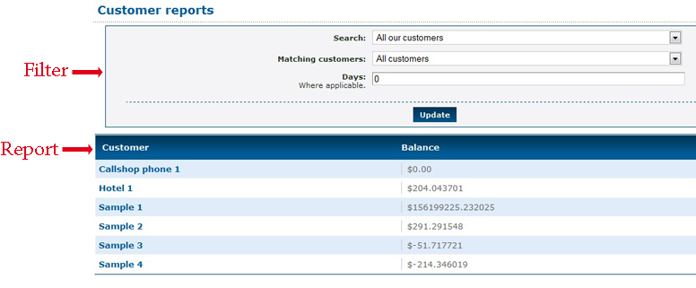
Some filters include start and stop time and date. Some include customer names, telephone numbers, and many other parameters that might be needed in a search.
To view reports:
        - Log in to the Enswitch web interface.
          - Go to Reports (on the home page, in the lower left corner), then select the type of report to create (see section 4.1, Report Types).
          - Select the appropriate options to filter and sort the report results.
          - Click Update.
          - When the report has a button marked Export as .csv, click this to download the displayed report. Depending on your browser configuration, this may download a file to your computer, or may open the results in a program which can read .csv files such as a spreadsheet application.

Alerts
Use Alert settings to be notified by email of abnormal or potentially fraudulent calls. For example, calls costing more than a certain amount to a certain destination can trigger an alert.
To create an alert:
        - Log in to the Enswitch web interface.
          - Go to Features » Alerts.
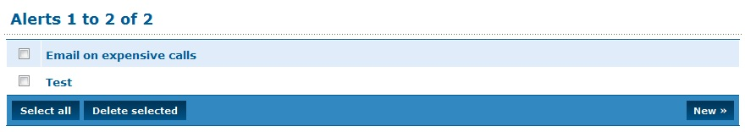
          - Click New to display the New Alert form.
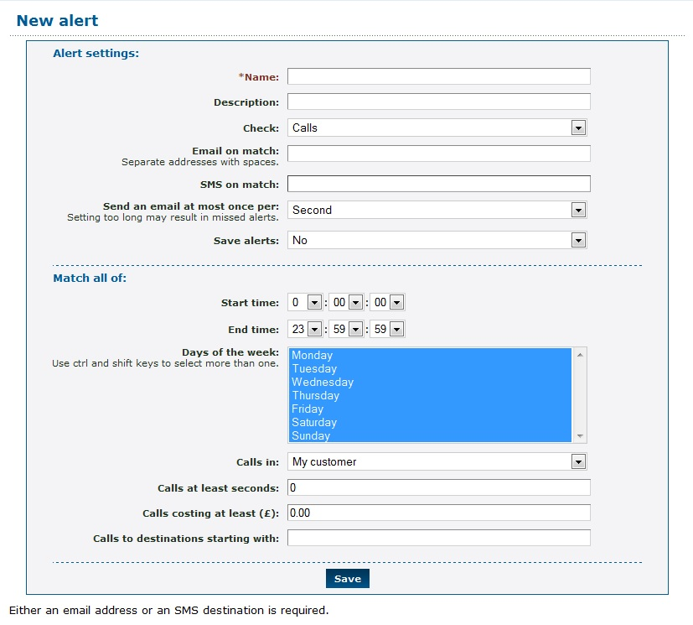
          - Fill out the Alert settings (fields marked with are required):
- Name: A unique name for the alert configured with this session.
            - Description: Description of the alert function. This appears on the Alert menu (see step 2).
            - Check: Enter which action to check for that causes the alert:
              - Calls, Calls to a peer: checked at the end of each call.
              - Destinations, Numbers: are checked daily.
              - Exceeding maximum calls.
              - Outbound groups: checked hourly.
              - Telephone lines are checked once per minute.
              - Telephones loosing registration.
            - Email on match: The email address to which to send the alert.
SMS on match: An SMS phone number to which to send the alert.
            - Send an email at most once per: The upper limit on how frequently to send alerts.
Note: if this is less frequent than the alert condition occurs, some alerts will be lost.
            - Save alerts: Enter whether or not to save sent alerts in the database. When this option is Yes, sent alerts can be viewed later using the new Alerts stored » link that appears at the bottom of the Edit alert page.
          - Enter the conditions to match alert events in the Match all of: section. All conditions must match to trigger the alert. Destinations can be an exact number, or can be a prefix.
          - Click Save.

Bulk Dialer
The bulk dialer allows you to make calls out to a large set of numbers, and any that are successful are forwarded to whatever destination you choose. The numbers to call are grouped into “campaigns”, which are sets of numbers with the same settings.
To create a campaign:
        - Log in to the Enswitch web interface.
          - Go to Features » Bulk dialer.
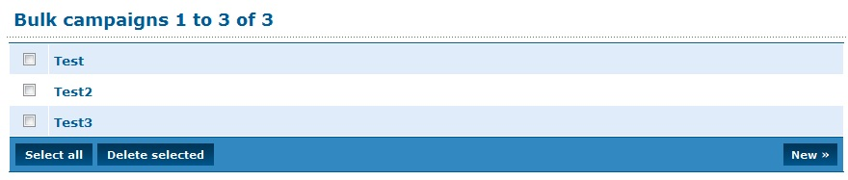
          - Click New to display the Bulk dialer form.
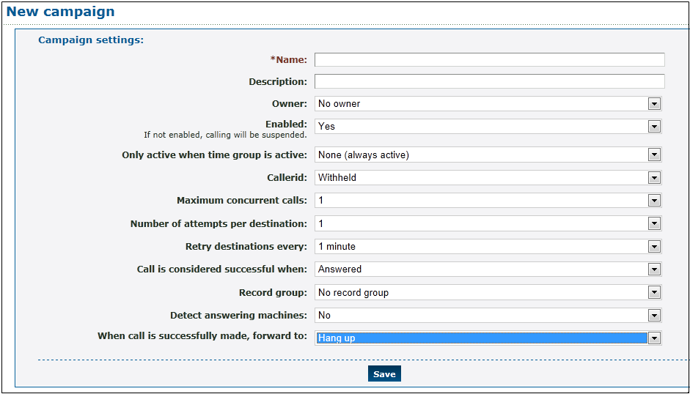
          - Fill out the form: (fields marked with are required)
- Name: Enter a unique name for the campaign.
            - Description: Description of the campaign. This appears on the Bulk dialer menu (see step 2).
            - Owner: Select the owner of the campaign. The drop-down menu includes No owner and any people enrolled in the system (see section 20, People).
            - Enabled: Enable/disable campaign. When No (disabled), calls are suspended. Return to the campaign later to enable it.
            - Only active when time group is active: Enter a time group. When a time group is selected, calls are only made when the time group is active.
            - Callerid: Enter the callerid to send on outbound calls. Choices include Withheld and any numbers enrolled in the system (see section 18, Numbers).
            - Maximum concurrent calls: Maximum number of calls allowed at the same time.
            - Number of attempts per destination: Number of times the dialer attempts to reach each number. The dialer is either successful or it gives up after this number of attempts.
            - Retry destinations every: Interval between dialing attempts.
            - Call is considered successful when: Action that defines the call as successful. When a call is unsuccessful, it will be retried.
            - Record group: Record group to record the call. Any valid group is available from the drop-down menu (see section 7, Call Recording).
            - Detect answering machines: When Yes is selected the system detects if there is an answering machine at the other end. This is experimental.
            - When an answering machine is detected: What to do when one is detected: Retry later, Mark as successful, Mark as failed.
          - In the section When call is successfully made, forward to: select where to send the call when it is successful.
          - Click Save.
          - Click Add destinations.
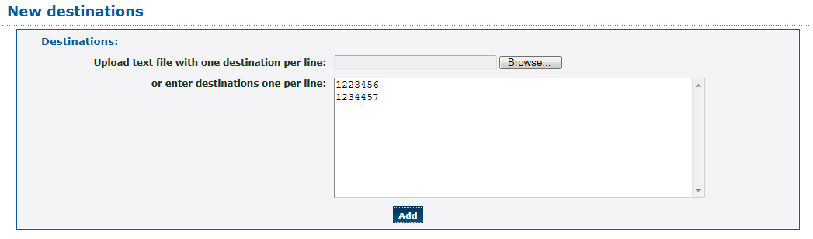
          - Either upload a text file with one number per line, or enter numbers one per line.
          - Click Add. At this point, if the campaign is enabled and the time window matches the current time, dialing starts.
After the main configuration is completed, you can upload a sound file to ask the called party to accept the call. You can also return and add additional numbers to the campaign.

Call Recording
Calls can be recorded in real time, and then downloaded as .wav files for future listening.

Call Recording Groups
To configure call recording:
        - Log in to the Enswitch web interface.
          - Go to Features » Call recording.
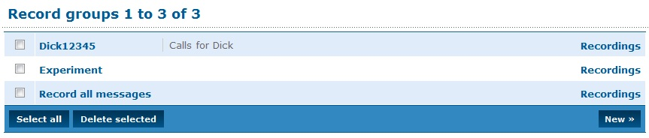
          - Click New to display the New Record group form.
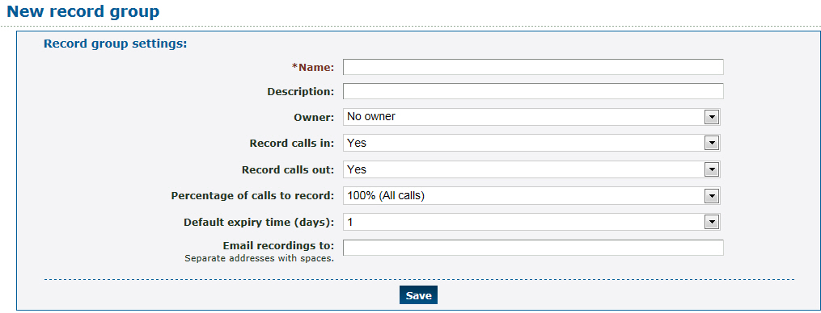
          - Enter the following: (fields marked with are required)
- Name: A unique call recording group name.
            - Description: Group description. This displays on the Record groups menu (above).
            - Owner: Defined owner is the only one allowed to access the group recordings.
            - Record calls in/out: Select which calls to record (calls in and/or calls out).
            - Percentage of calls to record: Select the percentage of calls to record.
            - Default expiry time (days): Default expiry time is the allowed time after a recording expires, before it is automatically deleted. Expiry times for individual recordings can be modified once they have been created.
            - Email recordings to: Enter an email address for sending recorded calls. Multiple email addresses should be separated with spaces.
          - Click Save.
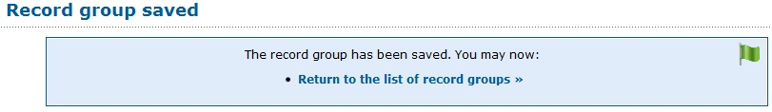

Record Inbox
To associate a call recording group with a telephone number:
        - Log in to the Enswitch web interface.
          - To record calls to this number, make a record group (see section 7, Call Recording).
          - Go to Features » Call recording.
          - To access the recordings, click Recordings on the right of the Record groups menu, or the Recordings link under the record group form.
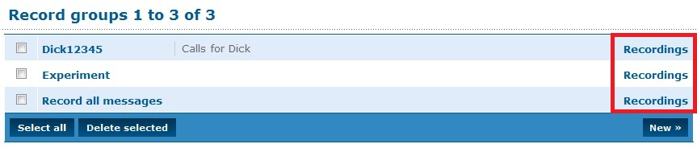
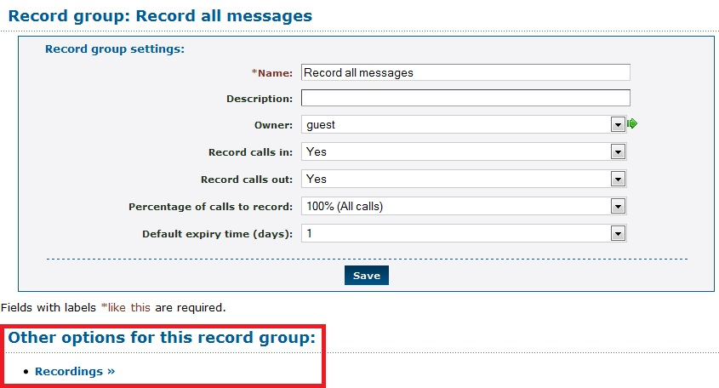
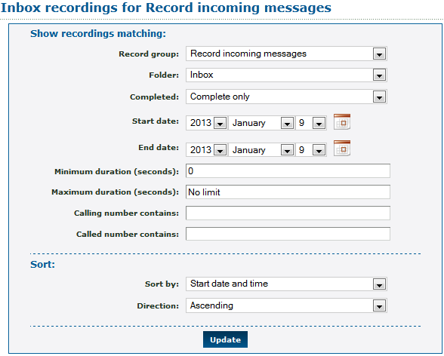
          - Enter the needed search parameters. Click Update. The system displays a list of recordings that match the search criteria.
          - To download a recording, click its link.
          - To work with recordings, select the desired recording. Click the appropriate button at the bottom.

Record Groups and Numbers Association
Select the numbers, telephone lines, for example, to use a specified group. When a call goes through to more than one number (of any valid type) that uses different record groups, the call is recorded to all designated groups.
In the settings for other features – for example, numbers and telephone lines – there is an option for selecting a record group.
To associate a call recording group with a telephone number:
        - Log in to the Enswitch web interface.
          - To record calls to this number, make a record group (see section 7, Call Recording).
          - Go to Features » Numbers.
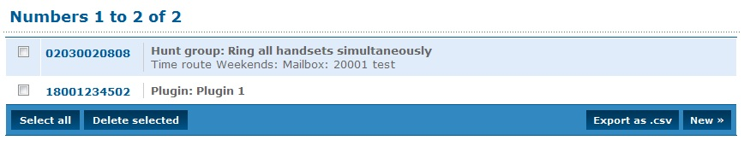
          - Click the number to associate.
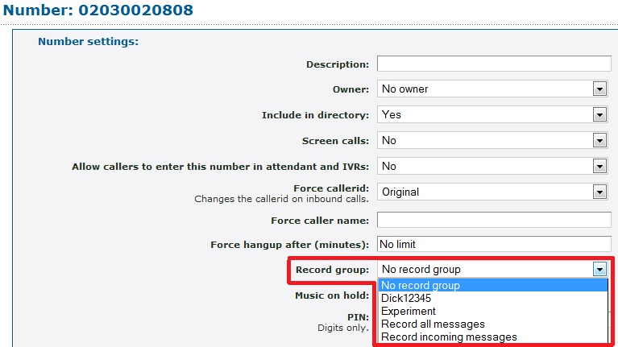
          - Select the Record group, and then click Save.
          - The system displays a list of recordings that match the search criteria.
          - To download a recording, click its link.
          - To work with recordings, select any you wish then click the appropriate button at the bottom.

Classes of Service
With Classes of service you control which numbers telephones can call. The called number is matched against the prefixes in the class of service, and the longest matching prefix is used. For example, calls to international numbers can be barred except for a single number which is specifically permitted. Alternatively, a single number can be barred if an employee is making unauthorized calls to it.

Add Class of Service
To create a class of service:
        - Log in to the Enswitch web interface.
          - Go to Features » Classes of service.
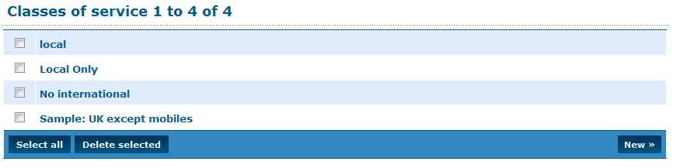
          - Click New to display the New class of service form.
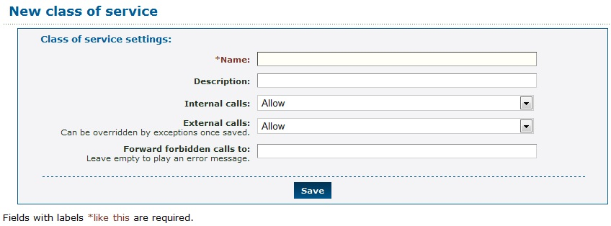
          - Enter the following: (fields marked with are required)
- Name: Class of service name.
            - Description: Description of the service. This appears on the New class of service menu (see step 2).
            - Internal calls: Either Allow or Forbid. When set to Allow, internal and external calls are allowed by default. At this point you cannot enter specific destinations.
            - External calls: Either Allow or Forbid. When external calls are forbidden the calls are forwarded to the specified number entered in the Forward forbidden calls to: field. Otherwise an error tone plays to the caller.
            - Forward forbidden calls to: A valid telephone number to forward forbidden calls.
          - Click Save.
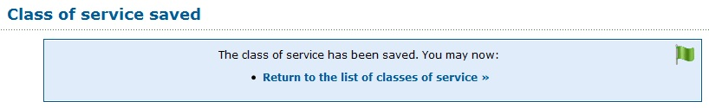

Class of Service Exceptions
When external calls are forbidden, you can identify numbers that are allowed. When external calls are allowed, you can identify numbers that are forbidden.
To create exceptions to the external call setting:
        - Click Return to the list of classes of service.
          - On the Classes of service list, click the class you created.
          - The Class of service page now displays an External exceptions section below Class of Service. Click New to display the New exception form.
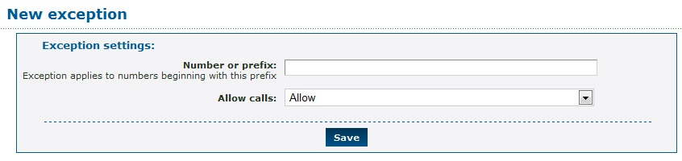
          - Number or prefix: the full number or prefix.
          - Allows calls: choose Allow or Forbid.
          - Click Save.
          - Add any other exceptions as needed.
          - In the settings pages for the telephone lines, there is an option for the Class of service. Configure any telephone lines that need this class of service.
        - Go to Features » Telephone lines and click on a selected line. In the Line settings section there is a Class of service option.
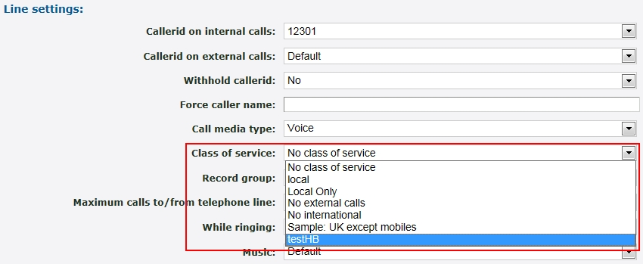
Select the class of service from the drop-down menu and click Save.
Any telephone line not in a class of service can call any preconfigured number in the system.

Conferences
Conferences allow two or more people to call into the system and talk together.
To add a new conference:
        - Log in to the Enswitch web interface.
          - Go to Features » Conferences.
          - Click New to display the blank conference form. The conference code is automatically generated. It is, however, modifiable.
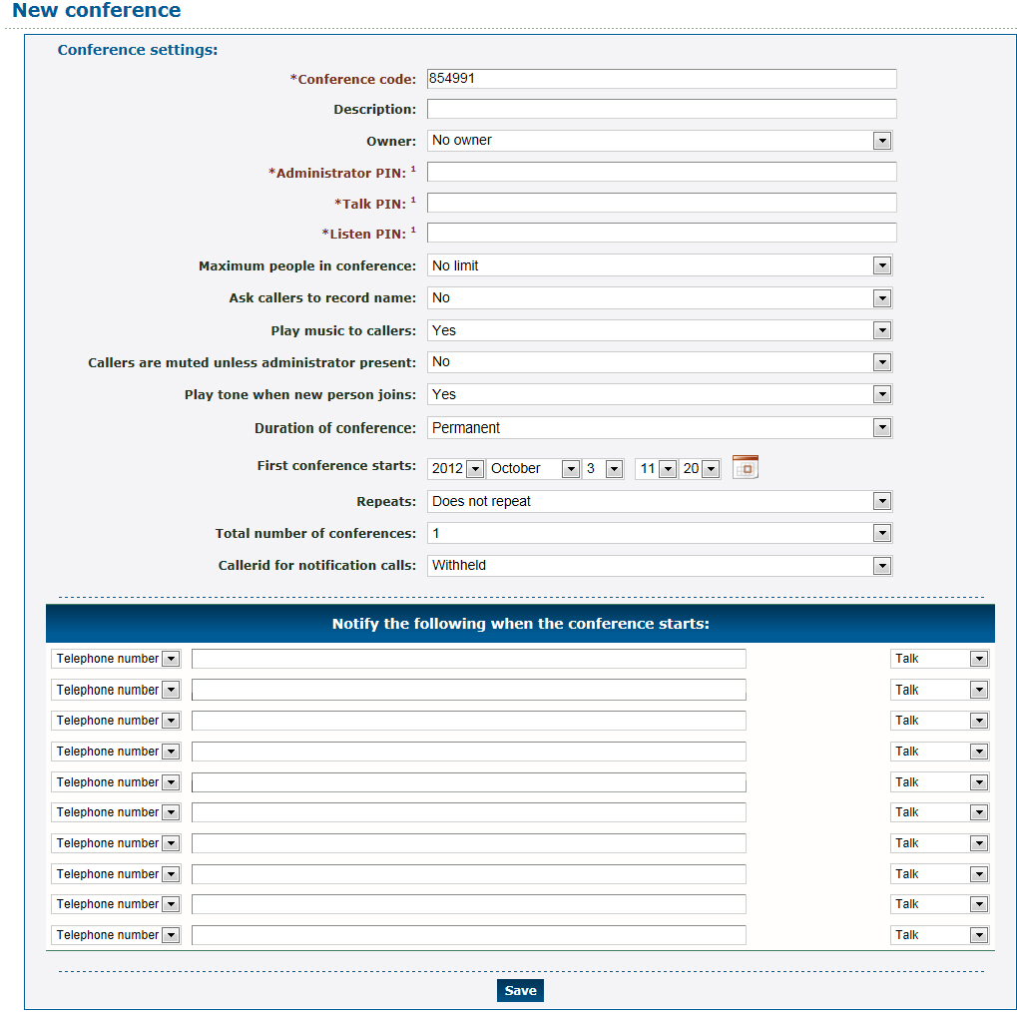
          - Enter the following: (fields marked with are required)
- Conference code: A unique, initially system-generated code (a six character number).
            - Description: This text displays in the list of conferences next to the conference code.
            - Owner: Valid choices are limited to the people enrolled in the system (see section 20, People). The owner can edit the conference even without administrator permissions.
- PIN (three options):
              - Administrator PIN: Caller can lock the conference to new callers.
              - Talk PIN: Caller can talk and listen.
              - Listen PIN: Caller can listen but not to talk.
            - Maximum number of people: Maximum allowed in the conference. When a caller attempts to log in to the conference after it is full, the system plays an error message and disconnects the caller.
            - Ask callers to record name: When set to yes, the callers are asked to record their names.
            - Play music to first callers: When set to yes, music plays to the first caller until others join.
            - Callers are muted unless administrator present: Play music to all callers until an administrator joins: when set to yes, music plays to all callers until an administrator joins the conference.
            - Play tone when new person joins: Play a tone when someone joins or leaves the conference.
            - Duration of conference: Outside of this time, callers cannot log in to the conference. Callers already in the conference are not disconnected at the end. To have callers access the conference at any time, set the duration to permanent.
            - First conference starts: Set the time when the first conference starts. One minute before this time, the system sends notifications to the registered attendees. Use this option with permanent conferences to send notifications.
            - Repeats: the interval the conference repeats.
            - Total number of conferences: How many times the interval repeats. For example, when the first conference is on Monday, and the conference repeats daily with a total of five conferences, the last conference is on Friday.
            - Callerid for notification calls: Displays to the conference subscribers when the system sends a notification before the start of the conference.
            - Notify the following when the conference starts:
Enter the telephone numbers to call or email addresses to send notifications to just before the conference starts. The called users are not asked for a PIN, but are put directly into the conference with the access you set here (talk, listen or administrator).
          - Click Save.
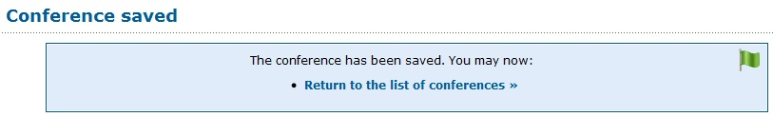
          - Set a number or feature code to forward to “Conference login”. *3 is set to conference login by default.
        - To set a number to forward to Conference login, go to Features » Numbers.
Click the desired number (such as 02030020808 in the above example).
In the Default destination section of the Number form, select what users are able to do if they call in to the conference (join the conference by entering a PIN, serve as an administrator, talk or just listen).
In the section below the Default destination section, select the conference by number.
To see the conference details associated with the default destination, click the green arrow to the right of the PIN entry.
Click Save.
To create a feature code that forwards to Conference login, go to Features » Feature codes, click New, and enter a unique feature code.
In the Default destination section of the form, select the conference by number as described in the previous steps.
Click Save.
          - Call this number or feature code when the conference is active. You are asked for a conference code and PIN. On entry you are connected to the conference.

Destination Features
The destination features are a collection of options for what happens when a caller connects to a specific number, feature code, or telephone line. The destination features are all alternatives to having somebody answer the phone. For example, if there is a telephone line not assigned to anybody, it could be set to hang up when somebody attempts to call it.
You can define a feature code to directly activate one of the destination options such as Redial last number.

Location of the Destination Feature Setting
The following features have a destination feature setting. The setting is called Feature and is located in a subsection of the configuration form for each feature that supports it:

Feature | Section in Form
Feature Codes | Default destination
Numbers | Default destination
Telephone lines | On no answer option
Queues | Destination to exit to
IVR Menu | Destination

Selecting a Destination Feature
Select the relevant feature from the Features list and then select the item to be configured. For example, the following screenshot shows part of the form for a Number. From the Default Destination drop-down menu, select the desired option, and then click Save.
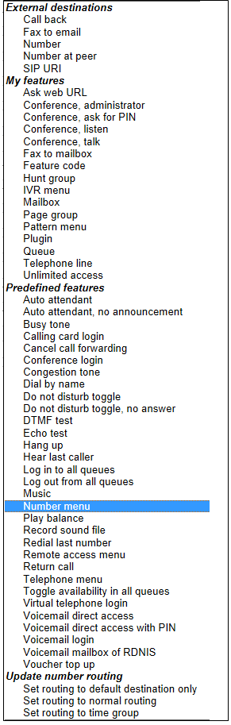
These are some of the options:
- Auto-attendant: A recording asks the caller to enter a feature code or telephone line belonging to the customer, and forwards the call to the destination entered.
- Auto attendant (no announcement): Waits for the caller to enter a feature code or telephone line belonging to the customer, and forwards the call to the destination entered. No announcement is played.
- Calling card login: A recording asks the caller to enter a valid calling card number, then a destination to call. The card used may be any card belonging to any customer on the system.
- Cancel call forwarding: If called from a telephone line, cancels the “Forward all calls to” setting for that telephone.
- Conference login: Asks caller for a conference code and PIN. If correct, puts caller in that conference with whatever access their PIN allows.
- Dial by name: Plays the dial by name menu.
- Do not disturb toggle: You can set up a feature code to toggle between “do not disturb” and allowing the call to go through. If the feature code is called from a telephone or external destination for a hunt group or queue, it toggles “do not disturb” for that telephone or external destination. When the toggle is in the “do not disturb” state, the call will be transferred to (where?) if it is defined.
- Do not disturb toggle (no answer): Acts in the same way as “Do not disturb toggle”, except that it does not answer the call. Instead, the call keeps ringing.
- Echo test: Answers the call and plays back whatever the caller says to them.
- Hang up: Hangs up the call. This can used in conjunction with an announcement to create a number that simply plays a message then hangs up.
- IVR setup: Plays a menu which allows the caller, once authenticated by the IVR PIN, to record a new sound file for the IVR. This option is only available as a destination for IVR menus.
- Music: Answers the call, and then plays music until the caller hangs up.
- Number menu: Plays a menu which allows the caller to change the temporary routing of a number.
- Play balance: Plays your current balance, and then hangs up.
- Redial last number: If called from a telephone, forwards to the last destination called by that telephone.
- Remote access menu: Asks caller to enter details of a remote access account, then a destination to call.
- Replay menu: Replays the IVR menu. This option is only available as a destination for IVR menus.
- Return call: If called from a telephone, forwards to the last caller that called the telephone.
- Unavailable tone: Plays an unavailable tone to the caller.
- Virtual telephone login: Plays a menu to allow virtual telephones to log in.
- Voicemail direct access: If called from a telephone, puts caller in main menu of mailbox set by “Message waiting light uses mailbox” setting for that telephone without any further authentication.
- Voicemail login: Asks caller for a mailbox number and PIN. If correct, puts caller in main menu of that mailbox.
- Voucher top up: Plays a menu allowing caller to use a voucher to top up their balance.

Dial by Name
Dial by name enables callers to reach a person by entering characters of the name on their telephone keypad. Enable Dial by name by enabling the Dial by name destination feature (see section 10.2, Selecting a Destination Feature).
Callers can then call the number, feature code, or IVR destination and enter characters of the last name of the person they are trying to reach.
- When the system detects that multiple names match the keyed characters, it plays a recording of each name, giving the caller a number to press for each name.
- When there are more than ten matches, the caller is asked to enter more characters.
When the caller successfully chooses a match the call is transferred to the internal extension of the person called.

System Rules for Matching Names
When the system decides which recorded names to play that match what a caller has keyed, it starts with the people defined in the system and looks for the following, step-by-step. The first step that finds entries that match what the caller keyed is used to play back recorded names to the caller:
        - If there is a mailbox with the same number as the person's internal extension, and it has a name recorded, the name is used. Otherwise,
          - If the person is the owner of any mailboxes that have recorded names, the name of first one (sorted by mailbox number) is used. Otherwise,
          - If the person is the owner of any telephone lines which forward to mailboxes on no answer, and any of the mailboxes have names recorded, the name of first one (sorted by mailbox number) is used. Otherwise,
          - If the person is the owner of any telephone lines that are set to monitor mailboxes for message waiting, and any of the mailboxes have names recorded, the name of first one (sorted by mailbox number) is used. Otherwise,
          - The name of the person is spelled out letter by letter.

Dial By Name Configuration
To configure dial by name:
        - Log in to the Enswitch web interface.
          - Set a number, feature code, IVR destination, or feature to point to the dial by name feature (see section 10, Destination Features).
          - Go to Features » People.
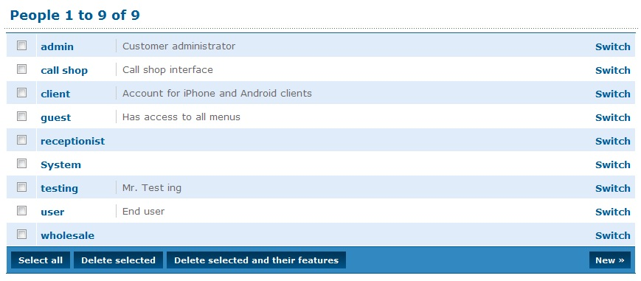
          - Click the name of the person file (the example below is “admin”, the first in the list above).
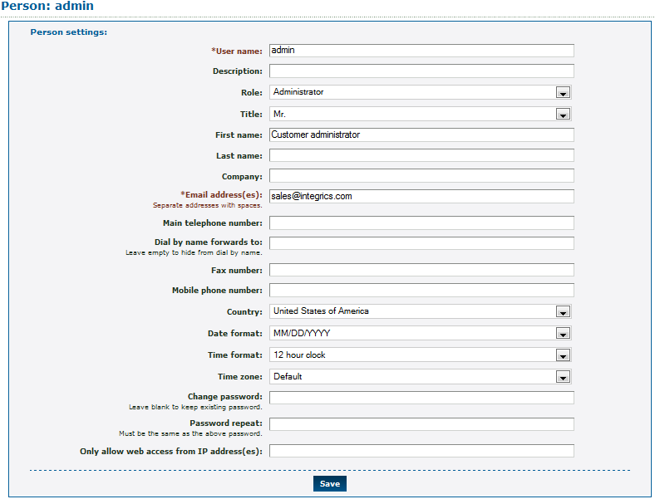
          - Set a mailbox to be owned by this person by going to Features » Mailboxes (see section 16, Mailboxes). Record the mailbox name using 0 (zero) then 3 from the voicemail main menu.
          - Repeat for any other people who are to be reachable by dial by name.

Feature Codes
Feature codes are short numbers used to call a particular telephone line, hunt group, destination feature, or other feature, from within the system. For example, you can set “123” to forward to a hunt group of all telephone lines. Feature codes are also used to access features such as voicemail. For example, *1 is often set to allow direct access to voicemail without a password, and *2 asks for a mailbox and password. You may change these assignments; this is useful if your staff is used to the feature codes of a legacy PBX system. Calls to feature codes are not charged. The feature codes that you create affect only users belonging to your own customer, and not other customers using the system.

Default Feature Codes
Some feature codes are defined within the system for you. These are:
- *1: Voicemail direct access.
- *2: Voicemail login.
- *3: Conference login.
- *4: Auto-attendant.
- *5: Number routing menu.
- **: Group pickup.
- ***<telephone line>: Pickup specific telephone line.
These options are not shown on the feature codes configuration page. If you create feature codes with these numbers, your feature codes override the defaults.

Add Feature Codes
To add a new feature code:
        - Log in to the Enswitch web interface.
          - To record calls made to this feature code, make a record group (see section 7, Call Recording).
          - Go to Features » Feature codes.
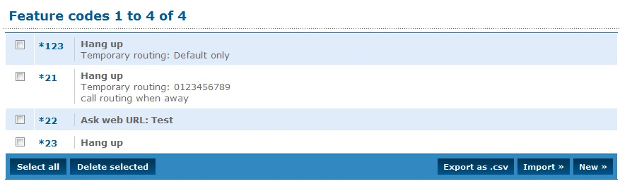
          - Click New.
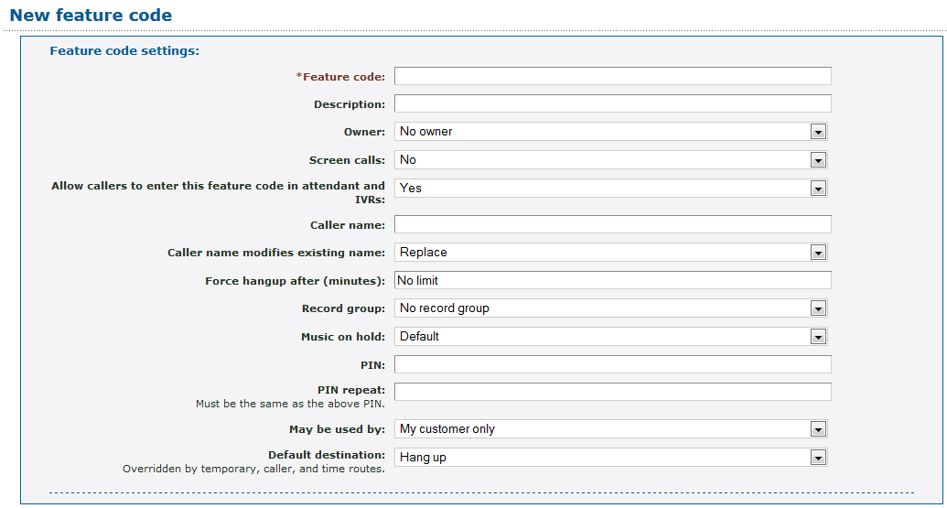
          - Enter the following: (fields marked with are required)
- Feature code: This must be a combination of numbers, *, and/or # (for example *123 or 123 or *123#).
            - Description: This text is displayed next to the code in the list of feature codes.
            - The Owner: This person may edit the feature code even if they are not an administrator.
            - Screen calls: When set to yes, the person answering is asked if they want to accept the call.
            - Allow callers to enter this feature code in attendant and IVRs: When set to yes, this feature code can be entered in the auto attendant and IVR menus.
            - Caller name: Allows users on a SIP telephone to see which feature code the call came from. If not set, the caller name supplied by the caller will be used.
            - Caller name modifies existing name: Determines whether the caller name setting above replaces the caller name supplied by the caller, prepends to it, or appends to it.
            - Force hang-up after (minutes): Hang up the call after a certain number of minutes.
            - Record group: Associates the feature code with a record group (see section 7, Call Recording).
            - Music on hold: When selected, users who dialed this code and are on hold will have music played back to them.
            - PIN: Digital password. You can call the number routing menu and change the temporary routing and announcement message.
            - PIN repeat: Must be the same as the PIN.
            - May be used by: When set to yes, the feature code can be used by all customers on the system (only set by system owner).
            - Default destination: Wehre the call is sent unless overridden. See section 10, Destination Features.
            - Temporary routing: Overrides the main routing in the default destination. When you use the number routing telephone menu, the temporary routing changes.
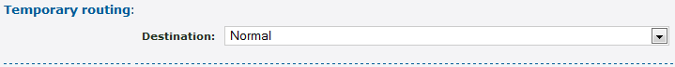
              - Destination: The choice is Normal (use the setting in the Default destination section).
          - Click Save.
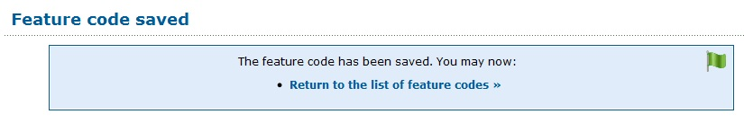
          - To set an announcement message to be played when the number is called, and before the destination is rung, go back into the feature code settings, and upload a .wav file. Alternately, call the number or feature code (*5 by default) for the number routing menu.
          - To route to different destinations for different callers, or at different times of the day or days of the week:
        - Create the feature code.
If routing by time, make a time group (see section 29, Times and Dates).
Go back into the feature code settings.
Click Add a caller route or Add a time group.
Choose the caller prefix or time group, and the destination.
Click Save.
Repeat for any other caller prefixes or time groups as needed.

Export Feature Codes
To export the features codes defined for your system:
        - Log in to the Enswitch web interface.
          - Go to Features » Feature codes.
          - Click Export as .csv.
The system downloads a file to your PC that is readable by spreadsheet applications.
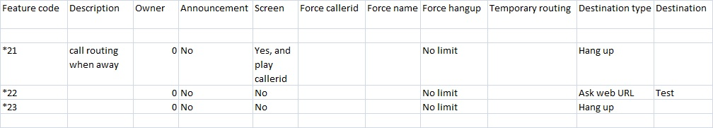

Import Feature Codes
To import feature codes (saved, for example, from another installation):
        - Log in to the Enswitch web interface.
          - Go to Features » Feature codes.
          - Click Import».
You are prompted to browse to a .csv file in the format shown in the prompt.
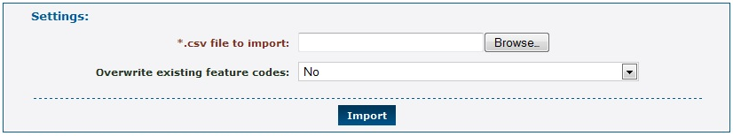

Feature Prefixes
Use Feature prefixes to modify the behavior of the call by adding a prefix to the called number. The system interprets the prefix and then strips it off before routing the call. A common example is keying 9 followed by an external number as way to connect externally.
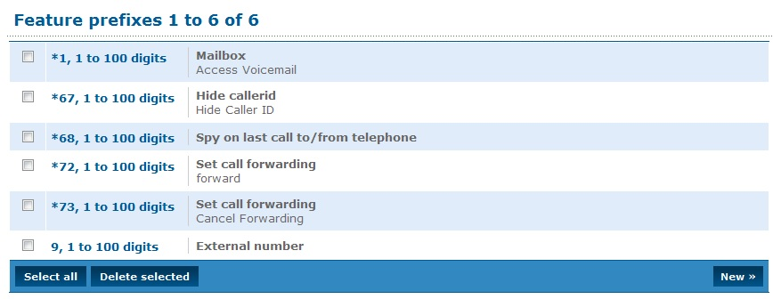

Purposes of Feature Prefix
The purpose of a feature prefix can be one of the following:
- Conference (three options): Join a conference without asking for the conference code. The caller can be asked for a PIN, or can be put directly in the conference as administrator, talker, or listener without being asked for a PIN.
- External number: This can be used to implement 9 for an outside line.
- Hide callerid: Use this to prevent your callerid being sent.
- Mailbox: Dial the prefix followed by a mailbox number to directly call that mailbox. This is useful for transferring external callers if you know the person you wish to transfer them to is unavailable.
- Page telephone: Page a telephone line.
- Park call: Park the call on a specific parking slot.
- Plugin: The plugin can access the remainder of the called number after the prefix using the ${ENSWITCH-SUBNUMBER} variable.
- Record call: If the choice is Yes, a drop-down menu appears with a choice of defined record groups. The record group can then be chosen.
Note: the record group settings, such as percentage of calls to record, still apply. Therefore it is possible that the call will not actually be recorded.
- Remote access: Use a remote access menu by dialing a single number. This is the feature prefix, followed by the remote access account followed by *, and the PIN followed by * (if the account has a PIN), and then the destination.
- Replace prefix: The prefix will be replaced by the “Replace with” value. This allows creation of short dials to external number ranges, or replacement of the international access code.
- Set call forwarding: Dial the prefix followed by a number to set call forwarding to that number for the telephone line you are calling from.
- SIP domain: Routes the call to a number that is in the specified SIP domain.
- Spy on last call (three options): Optionally, the spy can talk to the caller. A PIN can be specified to protect this feature.
- Telephone: Dial the prefix followed by a telephone line's account number to directly call that telephone line.
- Use voucher

Add Feature Prefix
To add a new feature prefix:
        - Log in to the Enswitch web interface.
          - Go to Features » Feature prefixes.
          - Click New.
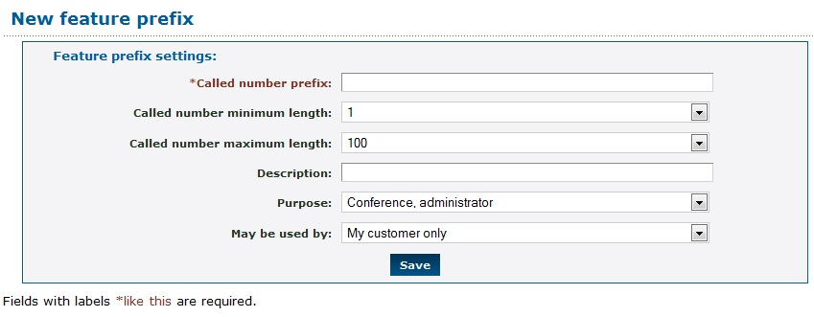
          - Enter the following: (fields marked with are required)
- Called number prefix: Unique prefix to match.
            - Called number minimum length: Minimum length of the called number to match. This includes the prefix.
            - Called number maximum length: Maximum length of the called number to match. This includes the prefix.
            - Description: This text is displayed next to the prefix in the list of feature prefixes.
            - Purpose: Purpose of the feature prefix. See 13.1 Purposes of Feature Prefix.
            - May be used by: When you are logged in as a system owner, you can select whether or not the feature prefix can be used by all customers on the system.
          - Click Save.
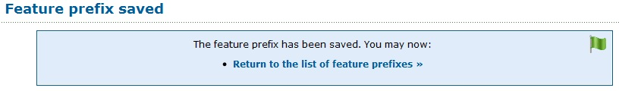

Hunt Groups
The Hunt groups feature allows more than one destination to ring at once. Within a hunt group, destinations are arranged into levels. All destinations within a level are rung at once. The first destination to answer hears the caller, and the others stop ringing (unlike page groups, where all destinations that answer are put into a conference). When no destinations answer after a defined interval, they stop ringing, all destinations in the next level are rung, and so on.

Types of Hunt Groups
A hunt group refers to the method of distributing phone calls from a single destination number to a group of several phone lines or groups of call agents. Specifically, it refers to the process, a type of hunt group, used to select which line receives the call. The automatic call distribution (ADC) routes incoming phone calls when they are answered by a computer phone system, based on the applicable hunt group.
The system processes incoming phone calls on a first come / first serve basis. Enswitch routes calls based up caller identification, dialed number, time of day, and custom defined parameters established in the IVR (Interactive Voice Response) program script.
There are two different types of hunt group assignments available:
- Linear Hunt Group: calls are always delivered to the lowest-numbered available line. This is referred to as busy/no-answer call forwarding. Calls are always delivered to the first line, unless it is busy - then the second, third, and remaining lines are considered in succession.
            - Linear: Always start at level 1 (the highest level)
            - Smart linear: Start with the last level that answered, then linear
- Circular Hunt Group: calls are distributed "round-robin". If a call is delivered to line 1, the next call goes to line 2, the next to line 3. When the end of the hunt group is reached, the hunting starts over at the first line. Lines are only skipped if they are still busy on a previous call.
            - Circular: Start at the next level from previous call
            - Smart circular: Start with the last level that answered, then circular

Add Hunt Groups
To add a new hunt group:
        - Log in to the Enswitch web interface.
          - To record calls made to this hunt group, make a record group (see section 7, Call Recording).
          - Go to Features » Hunt groups.
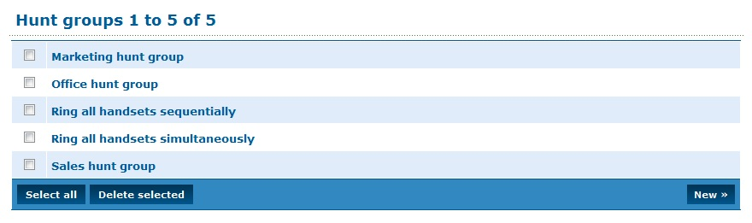
          - Click New.
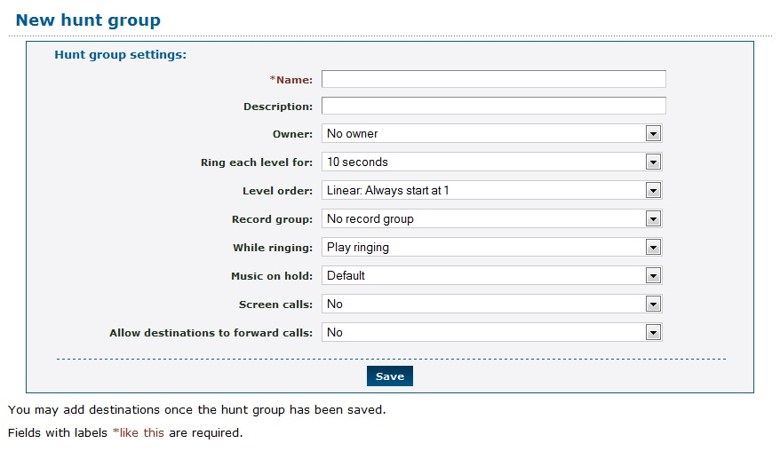
          - Enter the following: (fields marked with are required)
- Name: Hunt group name.
            - Description: Displayed with the hunt group name in the list of hunt groups.
            - Owner: The owner of the hunt group. This person can edit the hunt group even if they are not an administrator.
            - Ring each level for: Interval that each level rings before going on to the next level. This can be overridden per level later.
            - Level order: Hunt group type, which controls the order the levels are rung in. Options are “Linear: Always start at level 1”, “Circular: Start at next level from previous call”, “Smart linear: Last level that answered, then linear”, and “Smart circular: Last level that answered, then circular”.
            - Record group: Select the record group defined earlier.
            - While ringing: Choose whether or not to play music or ringing to the caller.
            - Music on hold: Music to play while caller is on hold.
            - Screen calls: Choose whether or not to screen calls. If set to yes, any destinations answering are asked if they accept the call. While the caller information is being played, other destinations continue to ring. The first destination to accept gets the call, and other destinations are dropped immediately.
            - Allow destinations to call forward: Choose whether or not to allow destinations to forward calls onwards. This is not recommended as it can cause loops.
          - Click Save.
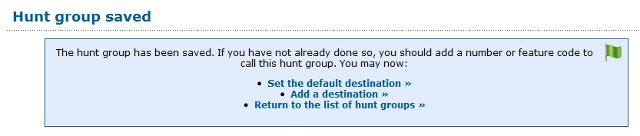
          - Click Set the default destination.
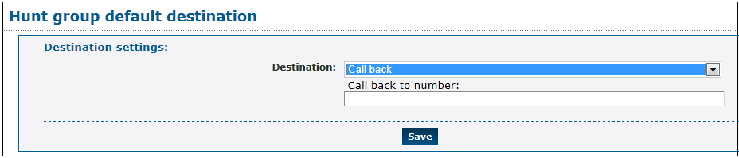
          - There are many possibilities for this parameter. One possibility is to enter a telephone number in the Call back to field. This number is the destination to call when there was no answer at all other destinations.
          - Click Save.
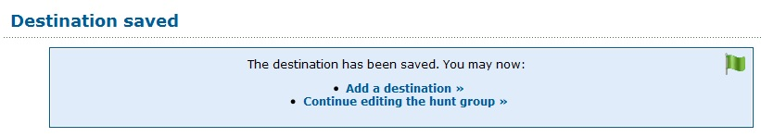
          - Click Add a destination.
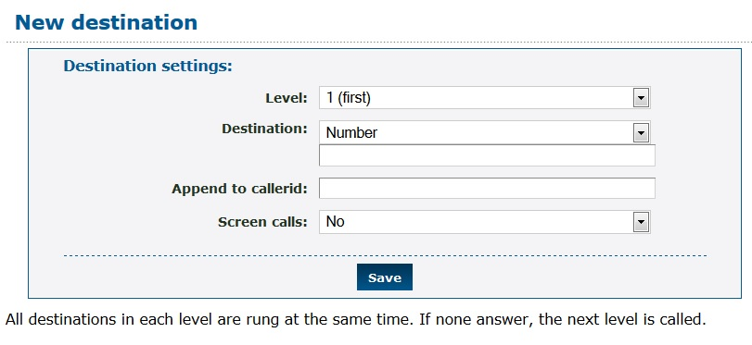
          - Choose the Level under Destination settings.
          - Choose the destination for the calls:
            - External destinations
              - Number
              - Number at peer
              - SIP URI
            - My features
              - Telephone line
          - Choose whether or not to screen calls.
          - Click Save.
          - Repeat for other destinations as needed.
          - Click Continue editing the hunt group. This returns control back to the Hunt group configuration form. Repeat from step 10 to add additional destinations and possibly additional levels.

IVR Menus
IVR menus present an audio menu to callers and invites them to press a key. It then forwards them to the destination you set for the key. Destinations can be other IVR menus, allowing multiple levels of menu.
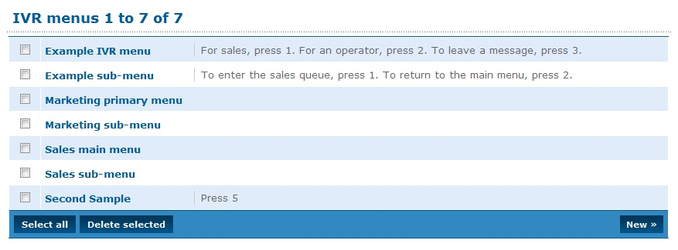

Add New IVR Menu
To add a new IVR menu:
        - Log in to the Enswitch web interface.
          - Go to Features » IVR menus.
          - Click New.
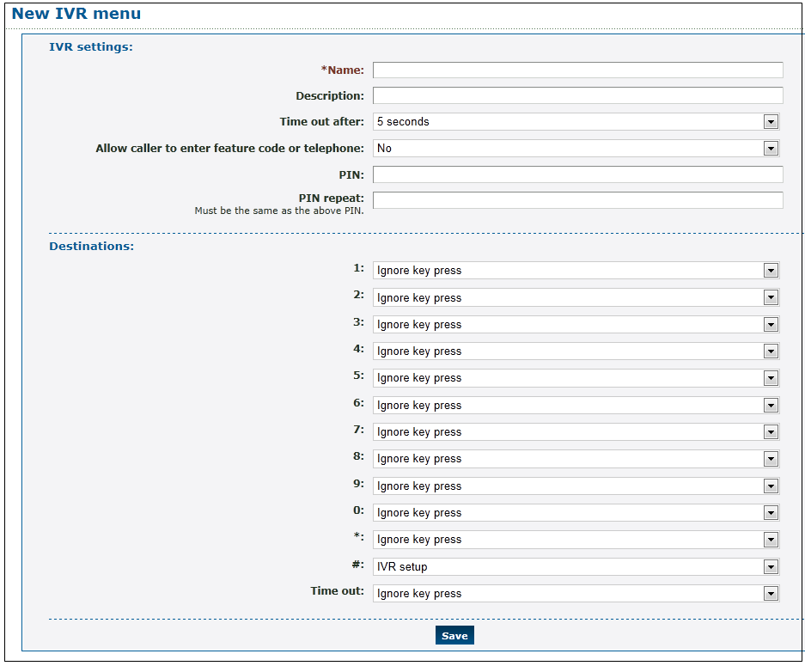
          - Enter the following: (fields marked with are required)
- Name: Menu name.
            - Description: This is displayed alongside the menu name in the list of IVR menus.
            - Time out after: How long to wait for the caller to press a key.
            - Allow caller to enter feature code or telephone: Whether or not callers can enter a feature code or telephone line.
Note: When this is set to yes, the system waits until the time out, even if the caller chooses a menu option. This allows the user time to enter a feature code or telephone line that begins with a digit that could be a menu option.
            - PIN: A PIN to allow you to change the message played to callers.
          - Click Save.
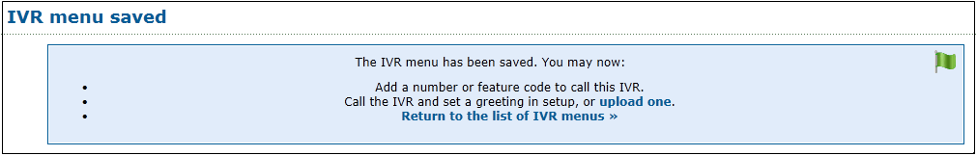
          - Click upload one. The Message files section appears under the Destinations section.
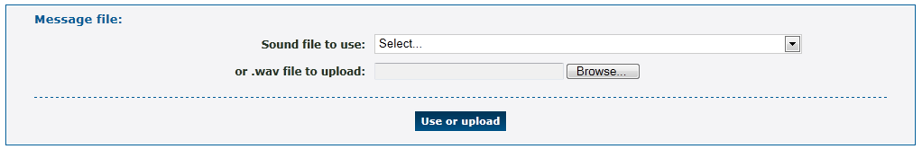
          - Upload a .wav file that is played to the caller. This audio message should explain the available options for this IVR menu.
          - Choose a destination for this key. This could be, for example, another IVR menu, a queue, a telephone, or a feature.
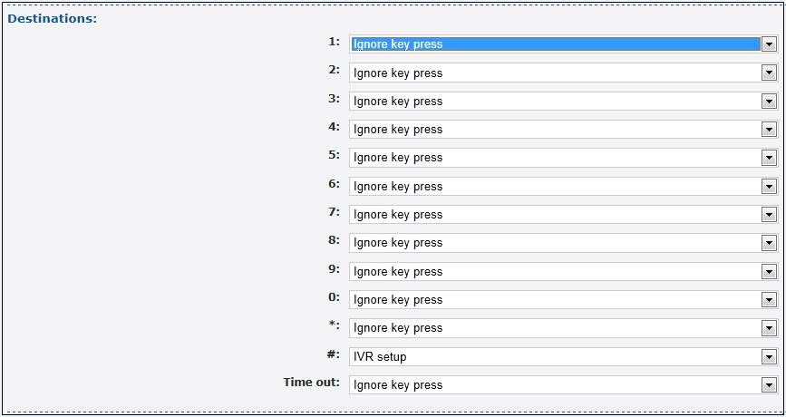
          - Click Save.
          - Repeat for other keys as needed.
          - Set a number, telephone line, feature code or another IVR menu to refer to this IVR menu as a destination. For example,
        - Go to Features » Numbers.
Click a number.
In the Default destination section, select IVR menu
Select the IVR menu you created from the drop-down menu.
Click Save.
Alternately, call the IVR menu and click the IVR setup key (# by default). Then enter the IVR Menu PIN. You will have the following choices: 1: play the current IVR menu message; 2: record a new IVR menu message; 3: delete the IVR menu message.

Mailboxes
Mailboxes can be owned by a person. When this owner has an email address set, an email with an attached .wav or .pdf file is sent for each message saved. It is normal, but not required, to have a mailbox for each telephone line. More than one telephone line, hunt group, or other instance of a feature, can share a mailbox.

Add New and Modify Mailboxes
To add a new mailbox:
        - Log in to the Enswitch web interface.
          - Go to Features » Mailboxes.
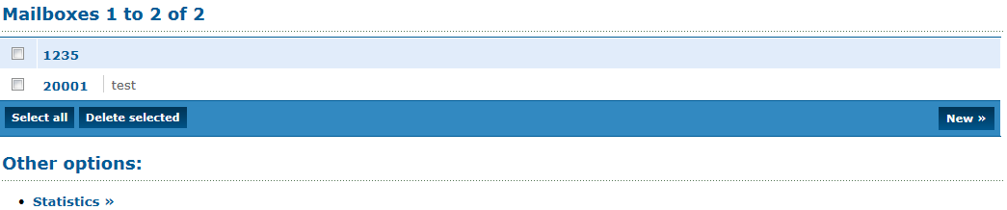
          - Click New.
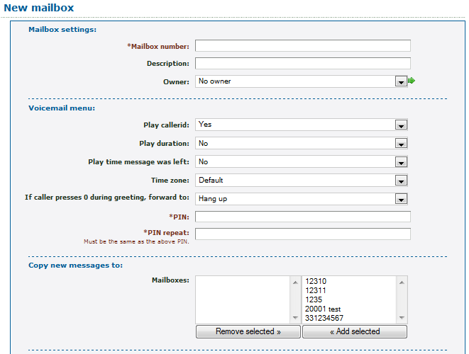
          - Enter the following: (fields marked with are required)
- Mailbox number.
            - Description: This description is displayed in the list of mailboxes.
            - Owner: If an owner is defined, that user can access the mailbox and modify the mailbox options without a PIN.
            - Voicemail menu: Settings for the menus to play when a user calls to retrieve messages – whether to play the callerid, the length of the message, and the time the message was received
- PIN: A PIN to access the mailbox.
- PIN repeat: Must be the same as the PIN.
            - Copy new messages to: If you have other mailboxes, select which mailboxes to copy any messages left in this mailbox and click Add Selected.
              - To remove a mailbox, select the mailbox and click Remove Selected.
            - Notification of new messages: A selection of other mailboxes that should be sent a copy of any messages left in this mailbox.
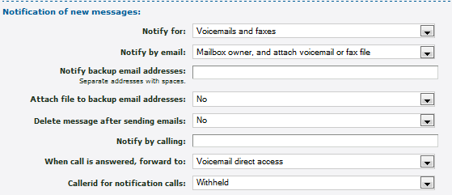
              - How to notify the mailbox owner when a new message arrives.
              - Where to forward the call if the caller press 0 (zero) during the greeting. This section includes all of the forwarding options of the system.
          - Click Save.
          - Set any telephone lines, hunt groups, or other features, to use the mailbox as a destination.

Mailbox Statistics
To display mailbox statistics:
        - Log in to the Enswitch web interface.
          - Go to Features » Mailboxes.
          - Click Statistics».
The system displays statistics for each mailbox.
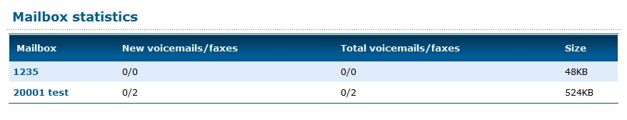

Music
The system plays a default music file while a caller is on hold. You can add additional music files and select which file to play.
Note: Be sure that you have permission from the copyright holder before adding a music file.
To add a new music file:
        - Log in to the Enswitch web interface.
          - Go to Features » Music.
          - Click New.
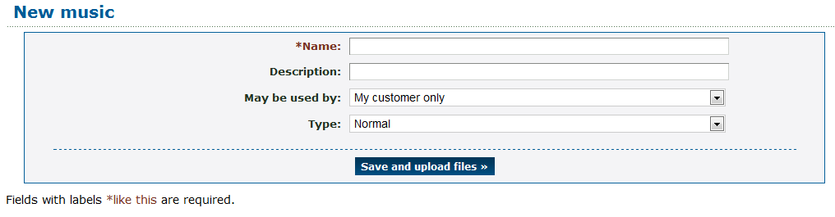
          - Enter the following: (fields marked with are required)
- Name: Music file name.
            - Description: This description is displayed in the list of music files.
            - May be used by: Select where this file can be used only by your customers or by all customers on the system.
            - Type: The default is normal. The file may also be configured in musiconhold.conf.
          - Click Save and upload files.
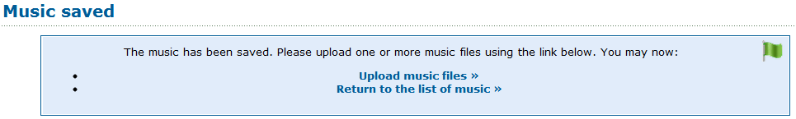
          - Click Upload music files.
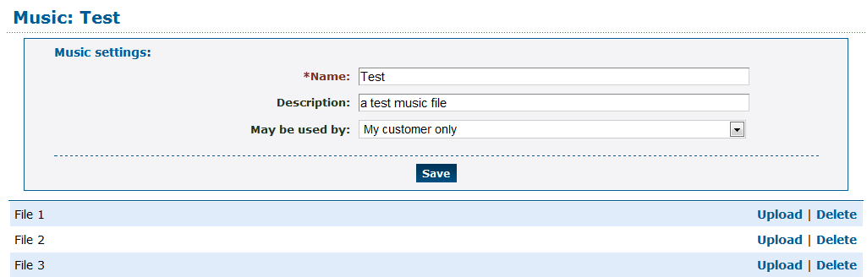
          - Click Upload for File 1 or the first available file.
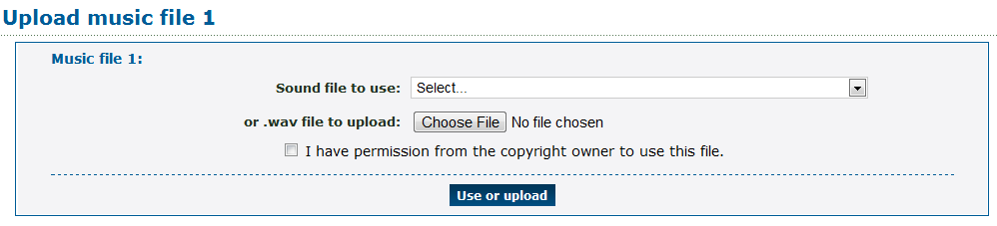
          - Either select a sound file that is already in the system or click Choose file and locate a file for upload.
          - Select the permission box; click Use or upload.
To use a music file:
Select the desired music on the settings pages for a feature that has music as an option, for example, telephone lines, hunt groups, or queues.

Numbers
Numbers, also known as DIDs or DDIs, are normal telephone numbers that external callers can use to call into the system from the Public Switched Telephone Network (PSTN).

Add New Telephone Numbers
To add a new number:
        - Log in to the Enswitch web interface.
          - To record calls made to this number, make a record group (see section 7, Call Recording).
          - Go to Features » Numbers.
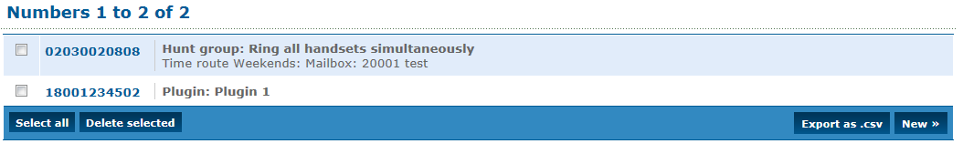
          - Click New.
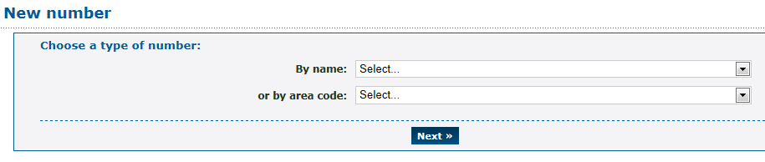
          - Choose the number type or by area code. The values in this menu will vary from installation to installation.
          - Click Next.
          - Choose a number. The price for the number is shown by the numbers. The available numbers are part of a higher level of provisioning. You can only select valid numbers.
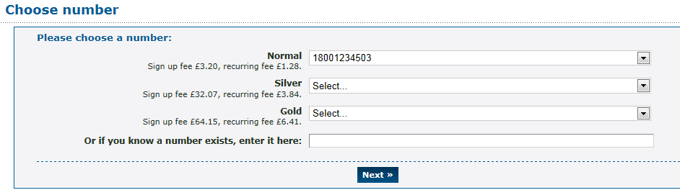
          - Click Next.
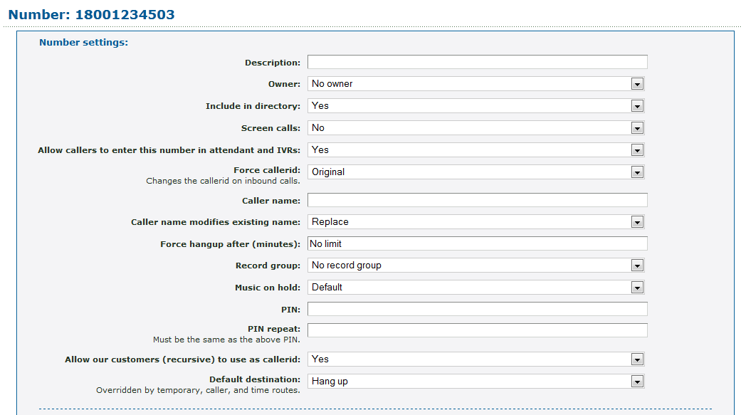
          - Enter the following: (fields marked with are required)
            - Description: Displayed in the list of defined numbers.
            - Owner: This person may edit the number even if they are not an administrator.
            - Include in directory: Select whether or not to include the number in the directory.
            - Screen calls: Select whether or not to screen calls. When set to yes, the person answering is asked if they accept the call.
            - Force callerid: This should normally be set to “Original”.
            - Caller name: This allows users on a SIP telephone to see which number the call came from.
            - Caller name modified existing name: Determines whether the Caller name setting above replaces, prepends to, or appends the caller name supplied by the caller.
            - Force hangup after (minutes): Force the call to hang up after a certain number of minutes.
            - Record group: The record group, if one was defined.
            - Music on hold: If set to yes, calls to this number will hear music when on hold.
            - PIN: If a PIN was defined, a caller who knows the PIN can call the number routing menu (*5 by default) and change the temporary routing and announcement message.
            - PIN repeat: Confirms the PIN.
            - Default destination: Calls can be directed to a selected destination, supported by the number form.
            - Temporary routing: This overrides the main number routing, as described in the next section. If you use the number routing telephone menu, it is the temporary routing that you change.
            - Destination: The temporary destination to route calls to when a call is received on this number.
              - Update this number when setting numbers routing: Select whether to update this number when using the number menu.
          - Click Save.
          - To set an announcement message to be played when the number is called, and before the destination is rung, go back into the number settings, and upload a .wav file. Alternately, call the number or feature code (*5 by default) for the number routing menu.
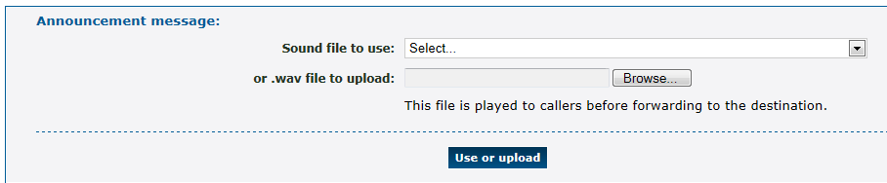

Number Routing
All of the system routing options are available on the number form
To route to different destinations for different callers, different times of the day or days of the week:
        - Create the number (see section 18.1, Add New Telephone Numbers).
          - If you are using routing by time, make a time group (see section 29.1, Create a New Time Group).
          - Go back into the number settings.
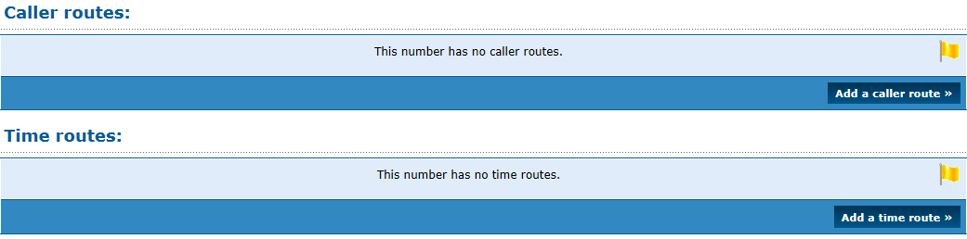
          - To add a caller route, click Add a caller route.
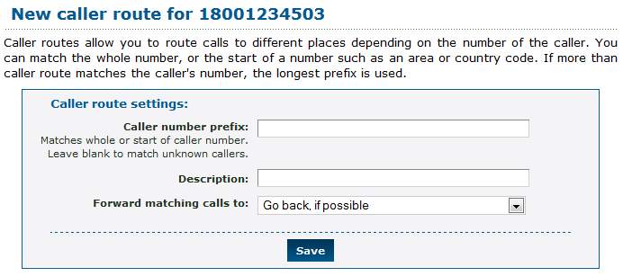
        - Add a calling number prefix: all calls that match the prefix will be forwarded based on the following setting.
Add a description that is displayed on the number page in the list of caller routes.
Select a forwarding option.
Click Save.
          - To add a time group, click Add a time group.
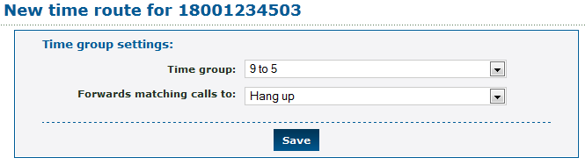
        - Select a time group.
Select a forwarding option.
Click Save.
          - Repeat for any other caller prefixes or time groups as desired.

Pattern Menus
Pattern menus allow highly flexible routing based on the called number, callerid, and optional digits entered by the caller. Matching on each can be done on exact strings, substrings, or MySQL style regular expressions. This allows call flows built on account numbers, passwords, postal or zip codes, or similar data.

New Pattern Menus
To add a new pattern menu:
        - Log in to the Enswitch web interface.
          - Go to Features » Pattern menus.
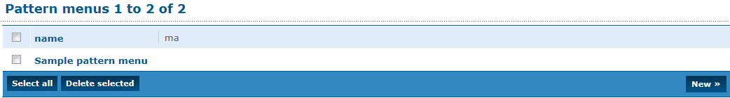
          - Click New to display the New pattern menu.
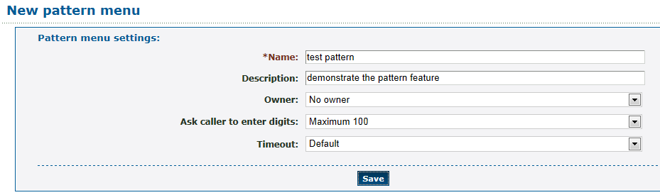
          - Enter the following: (fields marked with are required)
- Name: Pattern menu name.
            - Description: This value is displayed in the list of patterns.
            - Owner: This person may edit the pattern menu even if they are not an administrator.
            - Ask caller to enter digits: Select whether or not to ask the caller to enter digits, and if so, how many.
            - Timeout: When asking the caller to enter digits, select how long a timeout to allow between digits.
          - Click Save.

Add New Pattern
After the pattern entry has been defined, you can add patterns to the entry.
To add a pattern:
        - Click Add a pattern.
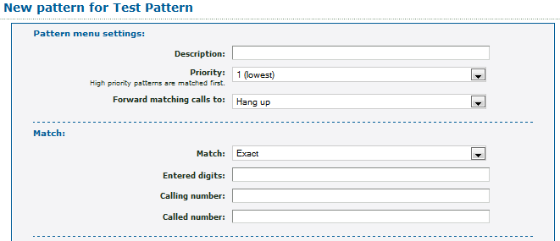
          - Enter the following: (fields marked with are required)
            - Description: These must be unique within a pattern entry.
            - Priority: When a higher priority pattern and a lower priority pattern both match, the higher priority pattern is used.
            - Forward matching calls to: The destination to route calls to if all three patterns match.
            - Match: Select whether or not to match the digits and calling/called numbers exactly, by substring, or by a MySQL style regular expression. (An example of a regular expression: ^1234 matches against any number that begins with 1234.)
            - Patterns to match against:
              - Digits
              - Calling number
              - Called number
            - Destination to route calls to when all three patterns match.
          - Click Save.
          - Repeat for other patterns as desired.
          - Set a number or feature code to point to this pattern menu.

Export Patterns
To export patterns:
        - Log in to the Enswitch web interface.
          - Go to Features » Pattern menus.
          - Click on the pattern to be exported.
          - Scroll to the bottom of the form.
          - Click Export as .csv. The system downloads the pattern. You can view or modify it in a spreadsheet or other application.
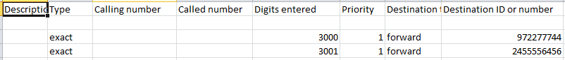

Import Patterns
To import patterns:
        - Log in to the Enswitch web interface.
          - Go to Features » Pattern menus.
          - Click on the pattern menu where you wish to import patterns.
          - Scroll to the bottom of the form.
          - Click Import.
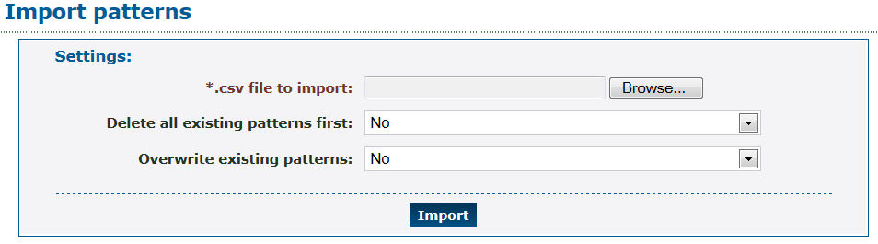
          - Browse to the file to import
          - Choose whether to delete all existing patterns in the menu or not.
          - Choose to overwrite existing patterns or not.
          - Click Import. The system will upload the file and add the patterns to the menu.
The imported file has the following format:
"<Description>","<Type>","<Calling number>","<Called number>","<Digits entered>","<Priority>","<Destination type>","<Destination ID or number>"

People
A person is anyone allowed to log into the web interface. When your customer has no people defined, you are unable to use the web interface. Your vendor can create the first person for you, so that you are able to add others.

Add New Person
To add a new person:
        - Log in to the Enswitch web interface.
          - Go to Features » People.
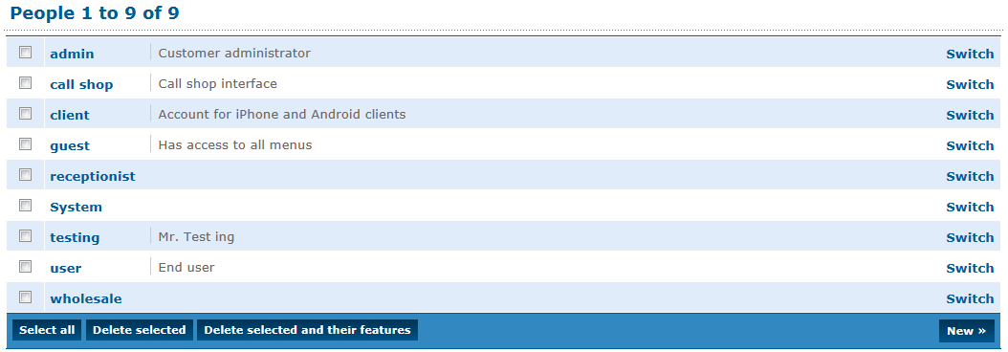
          - Click New.
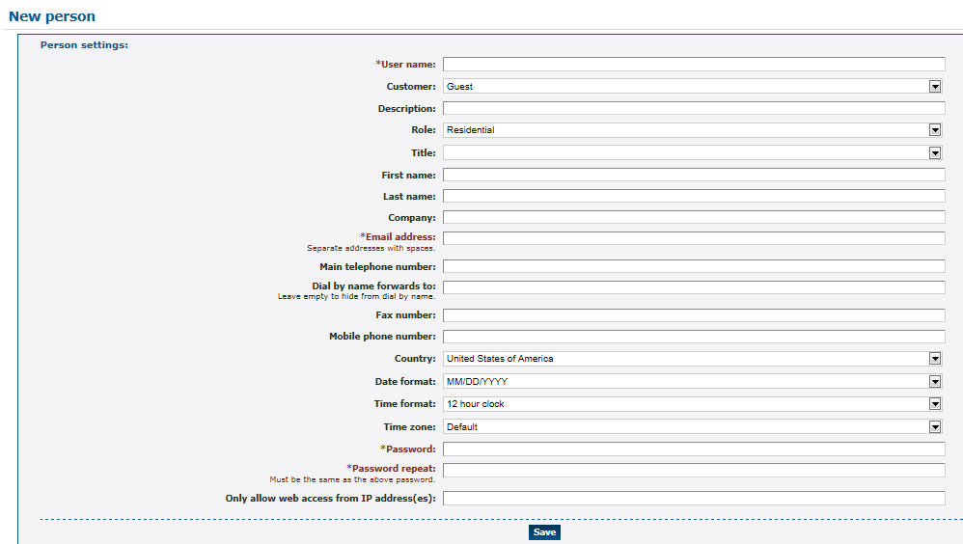
          - Enter a unique username. Email addresses are a good choice for usernames as they are unique.
          - Fill in the person's details as needed.
            - Customer: Select which customer this person is associated with.
            - Description: This text is displayed with any list of people.
            - Role: Places this person with a group of people with similar roles.
            - Title: A prefix to the person’s name (for example, Mr., Mrs., Dr.)
            - First name.
            - Last name.
            - Company.
- Email address: At least one is required. Additional email addresses are separated by a space.
            - Main telephone number: Primary number within the system.
            - Dial by name forwards to: When someone dials this person by name, connect via this number. If it is undefined, the system uses the main number.
            - Fax number.
            - Mobile phone number.
            - Country.
            - Date format.
            - Time format.
- Password/Password repeat: This password must be at between 4 and 20 digits.
            - Only allow access from IP address(es): Enter source IP address or an optional range of addresses. Ranges can be specified using CIDR netmasks, for example “192.168.0.0/16”. Multiple address and/or ranges can be entered, separated by spaces and/or commas, for example “10.0.0.0/8, 192.168.1.1”
            - Expect to be registered.
          - Click Save.

Switch Person
To switch to a different person:
        - Log in to the Enswitch web interface.
          - Go to Features » People.
          - Click Switch beside the person to whom you wish to switch. In this example the person is currently Guest and clicks Switch next to the Admin entry.
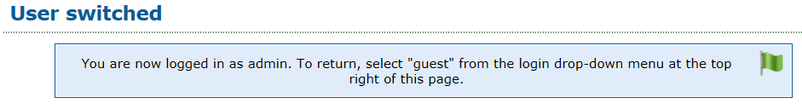
          - Do whatever actions you wish to perform as this person.
          - When you are done, return to Features » People and switch to the previous selection (for example, guest). Alternatively, you can log out using the select box at the top-right of the page.

Page Groups
Page groups allow more than one destination to be called at once. All destinations that answer are put into a conference, and can hear the caller. This differs from hunt groups, where only one destination can answer.

New Page Groups
To add a new page group:
        - Log in to the Enswitch web interface.
          - To record calls to this page group, make a record group (see section 7, Call Recording).
          - Go to Features » Page groups.
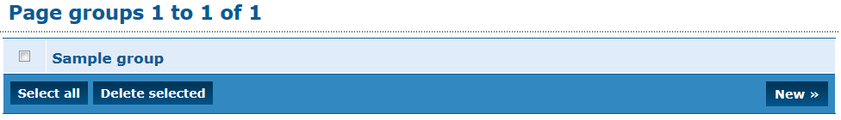
          - Click New.
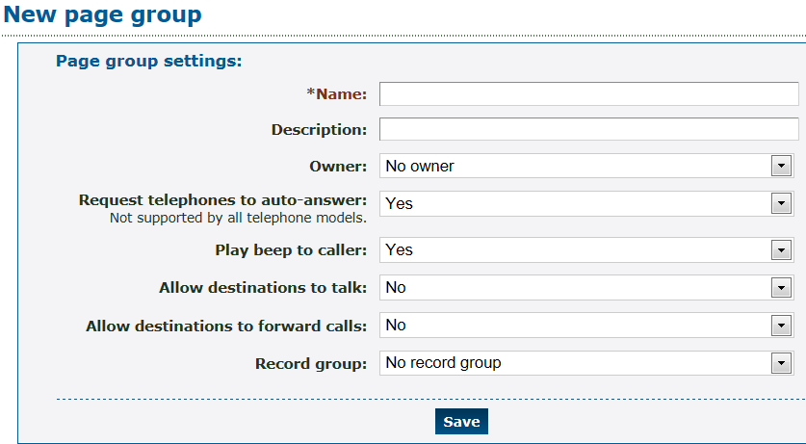
          - Enter the following: (fields marked with are required)
- Name: Page group name. This must be unique among all page groups
            - Description: Will be displayed with the group name in lists of page groups.
            - Request telephones to auto-answer: Select whether or not to ask SIP telephones to auto-answer. Not all telephone models support this. Any models that do not support this feature ring and do not auto-answer.
            - Play beep to caller: Select whether or not to play a beep to the caller when the caller is placed in the conference. Default is yes.
            - Allow destination to talk: Select whether or not destinations can talk. When set to yes, everyone in the conference can hear them. Default is no.
            - Allow destination to forward calls: Select whether or not to allow destinations to forward calls onwards. This is not recommended as it can cause loops. Default is no.
            - Record group: Select the name from the drop-down menu.
          - Click Save.
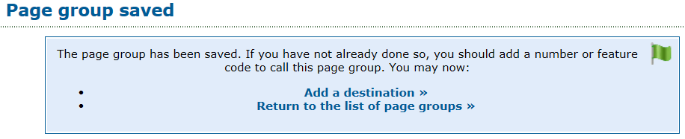

Page Group Destinations
Page group destinations are the telephone numbers that ring when a call’s specified destination is the page group.
To add a page group destination:
        - Click Add a destination.
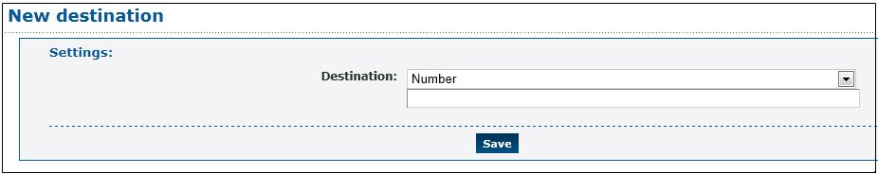
          - Choose the destinations:
            - External destinations
              - Number
              - Number at peer
              - SIP URI
            - My features
              - Telephone line
          - Click Save.
          - Repeat for other destinations as needed.
          - Add a feature code to call the page group (see section 12, Feature Codes).

Pickup Groups
When a telephone rings, other telephones in the same pickup group may dial **, which intercepts the call and brings it to them. Telephones can be in more than one pickup group, and can pick up any ringing telephone line in any group to which they belong. When more than one such telephone rings, which one is picked up is uncertain.
To add a new pickup group:
        - Log in to the Enswitch web interface.
          - Go to Features » Pickup groups.
          - Click New.
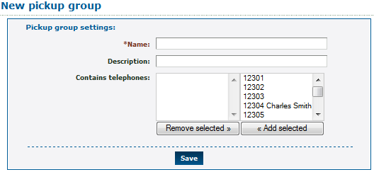
          - Enter the following: (fields marked with are required)
- Name: Pickup group name. This must be unique among all pickup groups
            - Description: Will be displayed with the group name in lists of pickup groups.
            - Contains telephones: Set those telephone lines that are members of this group and click Add Selected.
              - To remove telephone lines, select the telephone lines and click Remove selected.
          - Click Save.

Provisioning
Provisioning templates contain the data sent to telephone handsets when they request provisioning. The system owner configures which handset models are available. Work with your system owner to create customized templates.

New Provisioning Template
To add a new provisioning template:
        - Log in to the Enswitch web interface.
          - Go to Features » Provisioning.
          - Click New.
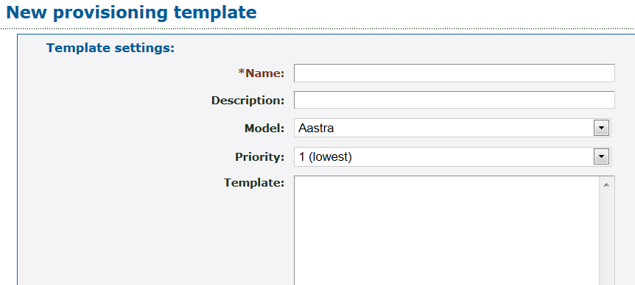
          - Enter the following: (fields marked with are required)
- Name: Template name.
            - Description: This text displays in the list of provisioning templates.
            - Model: Select a handset model from the drop-down menu that can use this template.
            - Priority: Priority of the template. When a telephone line is set to Automatic, the system detects the telephone model and then uses the highest priority template for that model.
            - Template: Text used to provision a handset. Any templates which are used via HTTP must start with a "Content-type" header, followed by a blank line.
          - Click Save.
          - Configure one or more telephone lines to use this provisioning template, or set the template choice to Automatic. Matching handsets will use the template with the highest priority.

Copy a Template
To make a copy of a provisioning template:
        - Log in to the Enswitch web interface.
          - Go to Features » Provisioning.
          - Click on the name of the template to be copied.
          - Scroll to the bottom of the template. Click Make Copy.
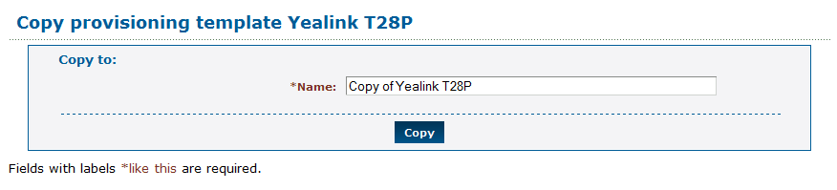
          - Give the template copy a name. Click Copy. The copy now appears in the list of template. You can now select the copy and edit the model, the priority and the template data.

Queues
Queues allow more callers than there are available destinations. Callers hear music on hold until a destination is free to take their call. Each destination is only sent one call at a time.

Adding a Queue
To add a new queue:
        - Log in to the Enswitch web interface.
          - To record calls to this queue, make a record group (see section 7, Call Recording).
          - Go to Features » Queues.
          - Click New.
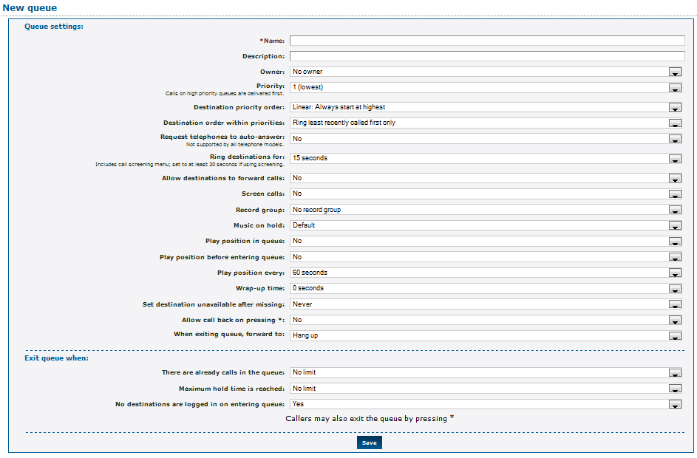
          - Enter the following: (fields marked with are required)
- Name: This must be a unique name among queues.
            - Description: This text is displayed next to the queue name in the list of queues.
            - Owner: This person can edit the queue even if they are not an administrator.
            - Priority: Calls on high priority queues get delivered first. Calls on queues of the same priority are delivered on a first come, first serve basis.
            - Destination priority order: Determines the next available destination.
              - Linear: Always start at level 10 (the highest level), or at the highest level defined.
              - Smart linear: Start with the last level that answered, then linear
              - Circular: Start at the next level from previous call
              - Smart circular: Start with the last level that answered, then circular
            - Destination order within priorities: The choice is to ring the next available line in the priority grouping or to ring all available lines in the grouping at once.
            - Request telephones to auto-answer: This only affects local SIP handsets, and only if the handset supports this feature.
            - Ring destinations for: Select how many seconds to ring the destination. When a destination does not answer, the call is returned to the queue and other destinations tried. If screening is enabled (the person answering gets to accept or reject the call), set this time to at least 20 seconds.
            - Allow destinations to forward calls: Selecting yes is not recommended as it can cause loops.
            - Screen calls: Select whether or not to screen calls. If set to yes, the destination is asked if they accept the call.
            - Record group: Record group to record the call. Any valid group is available from the drop-down menu (see section 7, Call Recording).
            - Music on hold: Provides an option for music or ringing on “hold”.
            - Play position in queue: Select whether or not to play the caller's position in the queue.
            - Play position before entering queue: Select whether or not to play the caller's position before entering the queue.
            - Play position every: How often to play the message and/or position.
            - Wrap-up time: Time interval between ending the last call from the queue and sending a new call from the queue. This gives the person time to finish up processing the previous call before taking on another one.
            - Set destination unavailable after missing: Select whether to log out destinations when they miss a certain number of calls.
            - Allow call back on pressing *: Select whether to allow calls to call themselves back upon reaching the head of the queue, and what callerid to use when calling them back.
            - When exiting queue, forward to: Calls to this queue are routed to this destination if none of the destinations answer before reaching the maximum hold time or maximum call number.
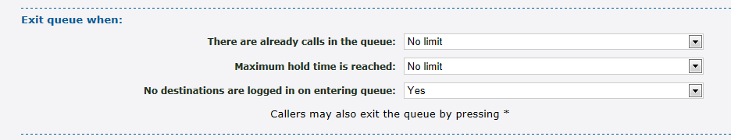
            - There are already calls in the queue: This is the maximum queue length. When additional calls try to enter the queue when the queue is full, they are sent immediately to the maximum calls or maximum hold time destinations.
            - Maximum hold time is reached: How long to hold for before giving up and exiting the queue.
            - No destinations are logged in on entering the queue: Select whether or not to exit when no destinations (IP handsets) are logged in to the queue when the call enters the queue.
          - Click Save.
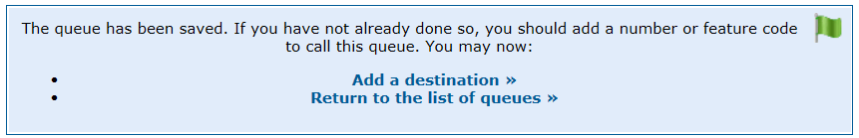

Adding Destinations to a Queue
To add a destination to a queue:
        - Click Add a destination.
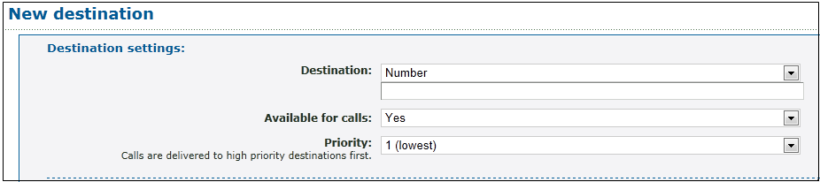
          - Choose the destinations.
            - External destinations
              - Number
              - Number at peer
            - My features
              - Telephone line
          - Enter the following: (fields marked with are required)
            - Available for calls: Indicate whether the destinations selected are available to accept calls from the queue.
            - Priority: Select a priority that will be used to decide which destination receives the next call on the queue.
          - Click Save.
          - Click Add another destination to redisplay the New destination form.
          - Repeat for other destinations as desired.
          - Go to Features » Queues. Click the queue name. Note that each phone line or number is listed separately in the destinations list.
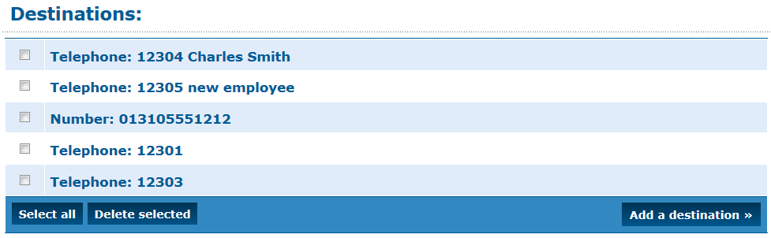

Add a Mechanism to Log In and Out of Queues
To add a way for users to log in and out from queues:
        - Optionally create one or more feature codes pointing to Log in to all queues, Log out from all queues, or Toggle availability in all queues. See section 10, Destination Features and section 12, Feature Codes.
          - Optionally make one or more numbers (or IVR menu destinations) point to Log in to all queues, Log out from all queues, or Toggle availability in all queues to allow external queue destinations to set their availability. See section 18 Numbers and section 15, IVR Menus.

Remote Access
The remote access mechanism allows calling in to the system and having the system then call out to another number. One application is to call in from home and have the system make a long distance call that connects back to the home number. Remote access takes one of three forms:
- Remote access menu: You dial in to a dedicated number. A menu then requests a telephone number to call. This is the most common use for remote access; if in doubt use this type.
- Call back to the callerid. With this method, you dial the remote access number, and hang up once you hear it ring. The system then calls you back based on the callerid. Once you answer, a menu requests a number to call.
- Dial the called number. The system directly calls the number you dialed after stripping off the authentication prefix. This type is only used to accept outbound calls from customers' SIP devices that cannot use normal SIP authentication. In this case, the device can add a secret prefix to the called number.
To add a new remote access account:
        - Log in to the Enswitch web interface.
          - Go to Features » Remote access.
          - Click New.
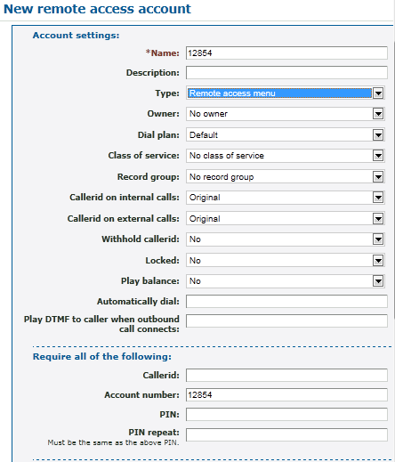
          - Enter the following: (fields marked with are required)
- Name: Account name. Must be unique among the remote access accounts.
            - Description: This text is displayed in the list of remote access accounts.
            - Type: Select whether or not to play the menu (Remote access menu), call back (Call back to the callerid), or place the call directly (Dial the called number).
            - Owner: Account owner.
            - Dial plan: Used for outbound calls when the system is configured for dial plans. This is the dial-out sequence for a selected country
            - Class of service: Select an applicable class of service. A class of service can, for example, block international calls.
            - Record group: Select a group if recording is required.
            - Callerid on internal calls: Telephone line to send to the caller.
            - Callerid on external calls: Number to send to the caller.
            - Locked: Select whether or not the account is locked. When locked, the account cannot be used.
            - Play balance: Select whether or not to play the customer's balance to the caller.
            - Automatically dial: Select whether or not to automatically dial a fixed number. When a value is set here, the caller is not asked for a destination.
            - Play DMTF to caller when outbound call connects: Enter a DMTF sequence to play to the caller.
            - Authentication options: All entered values must be matched by the caller for the call to go through.
              - Callerid: the caller must send a callerid that matches an entered value.
              - Account number: The caller-provided account number must match the entered value.
              - PIN: The caller-provided PIN must match the entered value.
          - Click Save.
          - When you set the type to be Remote access menu or Call back to the callerid, create a number pointing to the feature Remote access menu as the default destination.

Sound Files
Sound files keep a collection of useful recorded sounds that can then be used for other purposes such as mailbox greetings.

Create or Modify Sound Files
To create and use a sound file:
        - Log in to the Enswitch web interface.
          - Go to Features » Sounds.
          - Click New.
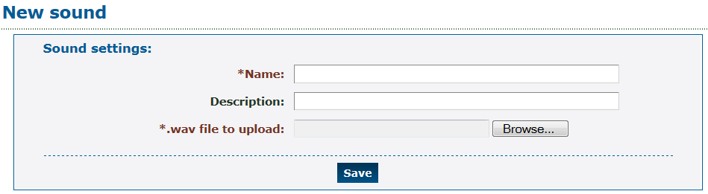
          - Enter the following: (fields marked with are required)
- Name: Sound file name.
            - Description: This text is displayed in the list of sounds.
- .wav file to upload: Browse to the file on your local computer or network.
          - Click Save.
          - Go to another feature such as mailbox.
          - On its edit page in the upload section, choose the sound file you've just created.
          - Click Use or upload.

Call to Record
The Call to record link under the sound files leads to a form to enter a number to call to record a new sound file. This sound file has an automatically generated name based on the date and time. You can rename it to something more using the technique listed above. You can also create a feature code pointing to the Record sound file feature to do the same.
        - Create a new feature code (see section Error! Reference source not found., Error! Reference source not found.).
          - In the Default destination drop-down menu, select Record sound file.
          - Click Save.
To call in a recording:
        - Log in to the Enswitch web interface.
          - Go to Features » Sound files.
          - Click Call to record.
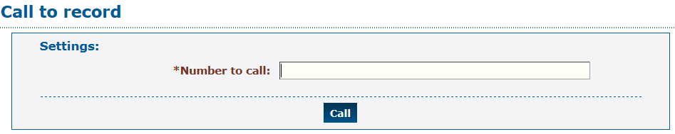
          - Enter the number to call.
          - Click Call. The system calls the number with a message asking you make a recording.
          - Follow the menu instructions to make and save the recording. The recording appears in the list of sounds.

Speed Dials
Speed dials enable users to dial destinations using fewer key presses. Speed dial also allows inbound calls from that destination to have their caller name forced to a particular value, creating a “nickname” for calls from that destination that is shown on handsets.
Speed dial entries can be shared, affecting all users within this customer, or they can be specific to one telephone line. Speed dials specific to one telephone line can be edited using the link at the bottom of the Edit telephone line form.

Create a Shared Speed Dial
To add a new shared speed dial:
        - Log in to the Enswitch web interface.
          - Go to Features » Speed dials.
          - Click New.
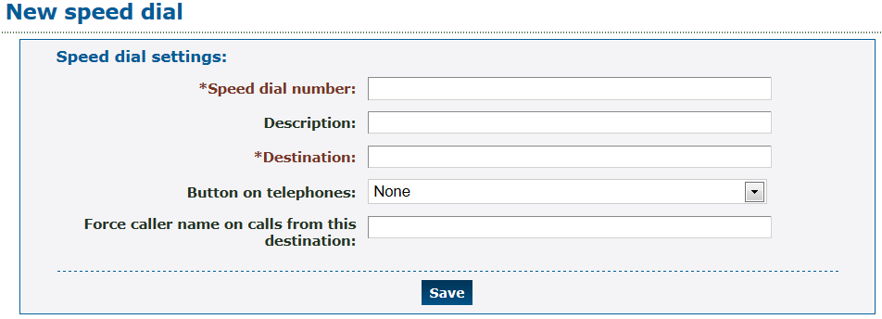
          - Enter the following: (fields marked with are required)
- Speed dial number: This is the number that users dial. This is typically one or two digits.
            - Description: This text is displayed in the list of speed dial definitions.
- Destination: Call destination – this can be a telephone line or an external number (for example, an external tech support service).
            - Button on telephones: Type of button on handsets to provision for this speed dial (when suitable automatic provisioning is configured). The options are defined in a drop-down menu.
            - Force caller name on calls from this destination: When a caller receives a call from the Destination, the system will display this string as a caller id.
          - Click Save.

Export Speed Dials
To export speed dial files:
        - Log in to the Enswitch web interface.
          - Go to Features » Speed dials.
          - Click Export as .csv.
The system downloads a file called speeddials.csv. Open this file with a spreadsheet or with some other application. The result is something like this:
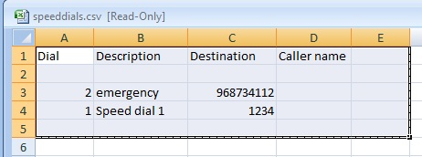
This file or a file in this format can be imported to define speed dial settings.

Import Speed Dials
To import speed dial files:
        - Log in to the Enswitch web interface.
          - Go to Features » Speed dials.
          - Click Import.
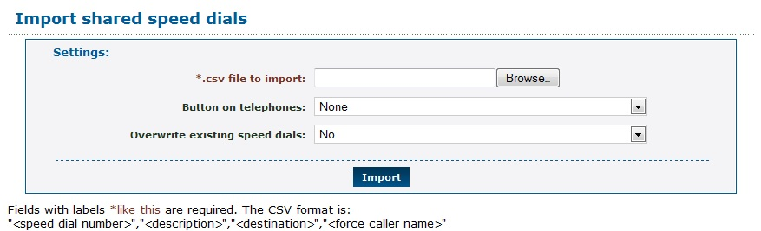
          - Browse to find a predefined .csv file
          - Select a Button on telephones setting for the imported speed dials.
          - Select whether speed dials in the file should overwrite existing speed dials with the same shortcut.
          - Click Import.

Telephone Lines
Telephone lines are the internal extensions of the telephone system. There configurations contain the information necessary to register SIP telephones on the system, and make and receive calls. Each telephone can have one or more lines.

Add a New Telephone Line
To add a new telephone line:
        - Log in to the Enswitch web interface.
          - Go to Features » Telephone lines.
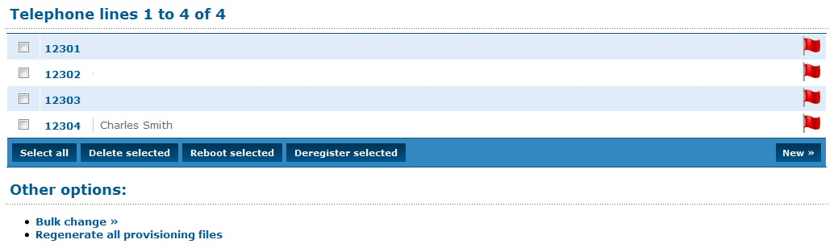
          - Click New.
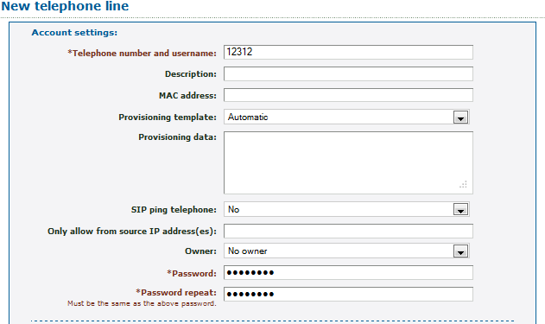
          - Enter the following: (fields marked with are required)
- Telephone number and username: The account number used to call the telephone within the system.
            - Description: Description of the new telephone line. This displays on the Telephone lines menu, next to the telephone username.
            - MAC address: A valid MAC address of the telephone, for example, 00:11:22:33:44:55-1. This is the MAC address of the handset associated with the telephone number.
            - Provisioning template: template to use (only when system is configured for provisioning). Select Automatic to let the system choose the best template. The other choices are restricted to the provisioning templates configured in section 23, Provisioning.
            - Provisioning data: Data provided by the system owner; this data is used to provision a specific model of SIP handset.
            - SIP ping telephone: Select whether or not to send SIP OPTIONS pings to the telephone. This is not normally required.
            - Only allow from source IP address(es): Required source IP address or range of addresses. Ranges can be specified using CIDR netmasks, for example “192.168.0.0/16”. Multiple address and/or ranges can be entered, separated by spaces and/or commas, for example “10.0.0.0/8, 192.168.1.1”
            - Expect to be registered: If the value is set to yes, the system sends an alert and flags the telephone line when it is not registered. If this value is set to no, there is no alert or red flag.
- Owner: Telephone owner. The owner must be one of the people enrolled in the system. Click the green arrow to the right of the drop-down menu to display the person’s details.
- Password/Password repeat: SIP password.
          - Scroll down the form to the Line Settings section.
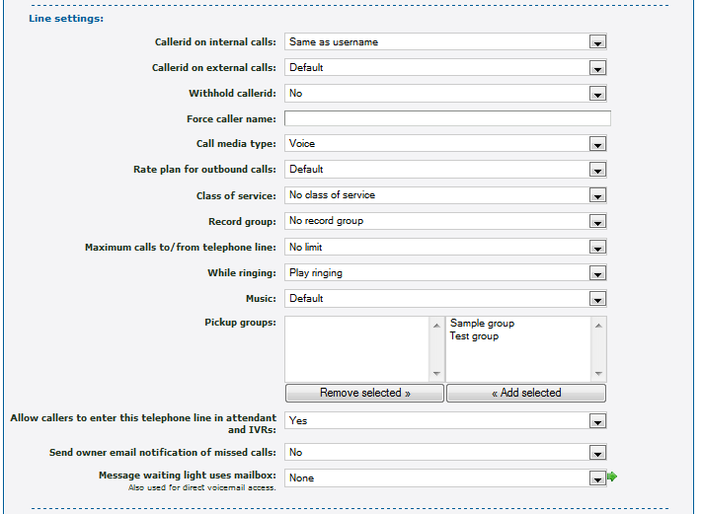
          - Enter the following: (fields marked with are required)
            - Callerid on internal calls: The callerid to send for calls within the system.
            - Callerid on external calls: The callerid is usually the one of the external numbers in the system.
            - Withhold callerid: Choose not send callerid for this telephone line.
            - Force caller name: When an internal telephone receives a call from this telephone line, the system will display this string as a caller id.
            - Call media type: Select whether the majority of the calls from this line will be FAX or voice.
            - Rate plan for outbound calls: (only valid when the system is configured for rate plans).
            - Class of service: A selection limits the range of destinations that a caller can make from this number.
            - Record group: Select a record group from the drop-down menu.
            - Maximum calls to/from telephone line: The maximum number of calls to allow to and from the telephone line.
            - While ringing: Select whether or not to play ringing or music when calling the telephone.
            - Music: Music to use when calling or on hold.
            - Pickup groups: Select groups to add this line to and click Add Selected.
              - To remove groups, select them and click Remove Selected.
            - Allow callers to enter this telephone line in attendant and IVRs: Select whether or not this telephone line can be entered in the auto attendant and IVR menus.
            - Send owner email notifications of missed calls: Select whether or not to send owner email notifications of missed calls.
            - Message waiting light uses mailbox: Select which mailbox to use from the drop-down menu. This is also the mailbox entered for direct voicemail access from the telephone line. When not set, calling voicemail from this telephone line always asks for a mailbox and PIN.
          - Scroll down to the User settings and Forward to sections.
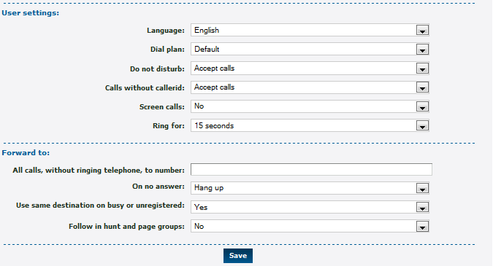
          - Enter the following: (fields marked with are required)
            - Dial plan: If the system is configured with multiple dials plans, select appropriate one.
            - Do not disturb: Select whether or not to set do not disturb. When set to yes, calls are forwarded to the destination below without ringing the telephone. This value is usually toggled with a feature code.
            - Calls without callerid: Select whether or not to accept calls without callerid. If not, calls without callerid are forwarded to the destination below without ringing the telephone. This value is usually toggled with a feature code.
            - Screen calls: Select whether or not to screen calls. When set to yes, the person answering is asked if they want to accept the call.
            - Ring for: How long to ring the telephone for before going to the destination below.
            - All calls, without ringing telephone to number: Enter the number to forward all calls to the telephone line.
            - On no answer: Select one of the options, as described in section 10, Destination Features.
            - Use same destination on busy or unregistered: When this parameter is set to Yes, no other value is required. If the value is No, there are two additional fields:
              - On busy: Make a selection as described in section 10, Destination Features.
              - On unregistered: Make a selection as described in section 10, Destination Features.
            - Follow this number in hunt and page groups:
          - Click Save.
          - Return to the list of telephone lines. The new line will be in the list.
          - Click the telephone line number. The displayed panel has additional fields added to it. Scroll to the bottom of the Line settings section.
          - Enter the following: (fields marked with are required)
            - Send called number as request URI: the No option is recommended.
          - Scroll down the form to the Virtual telephone section.
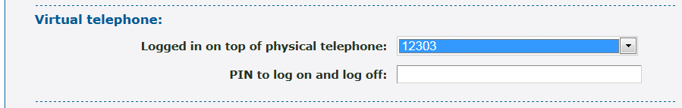
          - Enter a PIN to log on and log off: The owner of the phone uses this PIN to log onto another handset such that it is virtually the owner’s phone.
          - Click Save.
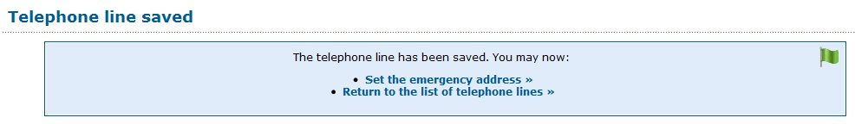
          - Click Set the emergency address. See section 28.3, Set the Emergency Address.
          - When a number forwards to the telephone line, add it.
          - Configure the account number and password on the SIP telephone. The following settings are recommended:
        - Most models of telephone should have NAT disabled as the server handles this. For more details, see section A, Telephone Models.
Register to a DNS hostname rather than an IP address. When the IP address changes, the telephone does not need reconfiguration.
          - For details on specific telephone models, see section A, Telephone Models.
          - Configure busy lamps (optional).
          - Create speed dials by clicking the Speed dials (see section 27, Speed Dials) link at the bottom of the edit telephone line page (optional).

View Call History
To view missed calls:
        - Log in to the Enswitch web interface.
          - Go to Features » Telephone lines.
          - Click the name of the telephone line. Scroll to the bottom of the form and click Call history.
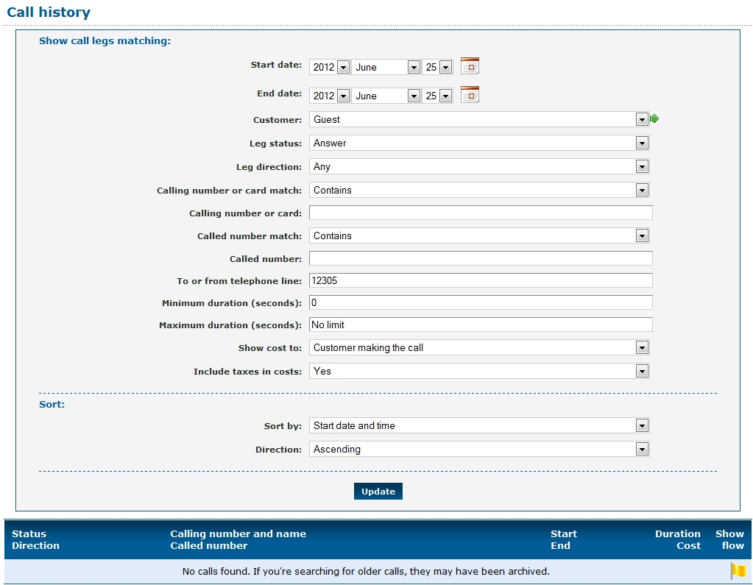
          - Enter the filter criteria for the report. Then click Update. The report displays under the filter criteria.

Set the Emergency Address
To add emergency information:
        - Log in to the Enswitch web interface.
          - Go to Features » Telephone lines.
          - Click the name of the telephone line. Scroll to the bottom of the form and click Set the emergency address.
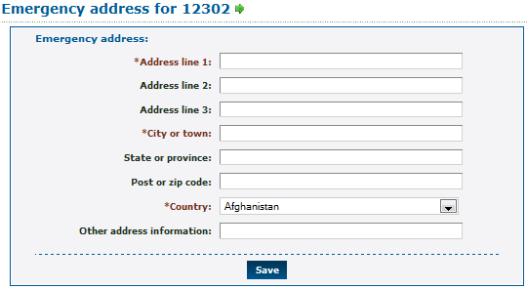
          - Enter the following: (fields marked with are required)
- Address line 1.
            - Address line 2.
            - Address line 3.
- City or town.
            - State or province.
            - Post or zip code.
- Country: select the country from the drop-down menu.
            - Other address information.
          - Click Save.
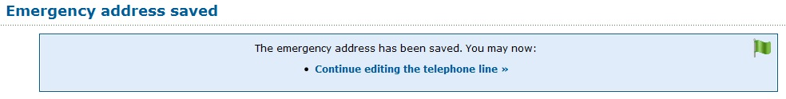

Display Missed Calls
To view missed calls:
        - Log in to the Enswitch web interface.
          - Go to Features » Telephone lines.
          - Click the name of the telephone line. Scroll to the bottom of the form and click Missed calls.
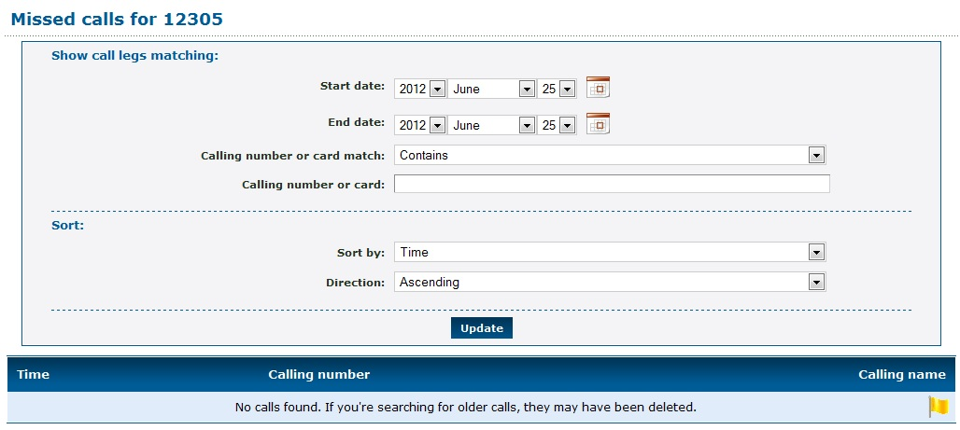
          - Enter the filter criteria for the report. Then click Update. The report displays under the filter criteria.

Times and Dates
Time groups support telephone numbers and feature codes that are routed to different destinations at different times of the day or days of the week. Examples of time groups might be:
- Every Saturday and Sunday
- Weekday evenings
- Every public holiday next year
Each time group is made up of one or more time periods that define when the group is active. The group is active when any of its time periods are active, and a time period is active when all of its criteria are met.

Create a New Time Group
To add a new time group:
        - Log in to the Enswitch web interface.
          - Go to Features » Times and dates.
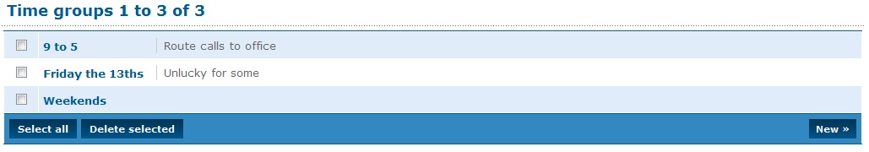
          - Click New.
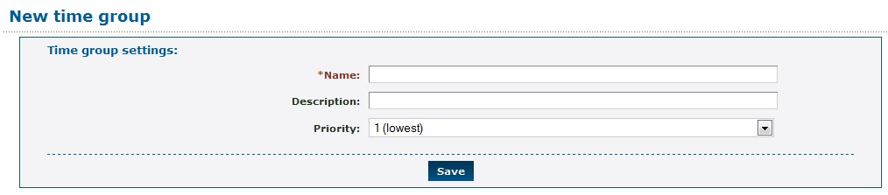
          - Enter the following: (fields marked with are required)
- Name: Unique name for this time group.
            - Description: Describe the group and its purpose. This displays on the Time group menu next to the name.
            - Priority: Time group priority. When a call is made to a number with more than one active time group, the group with the highest priority is used.
          - Click Save.
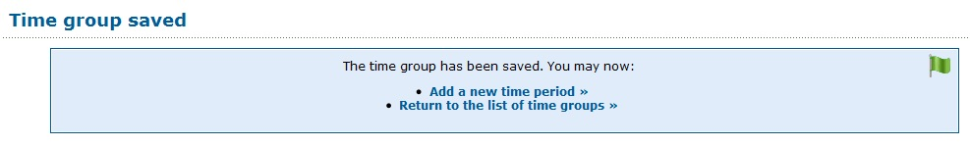
          - Click Return to the list of time groups.
          - On the Time groups menu, click on the newly created group.
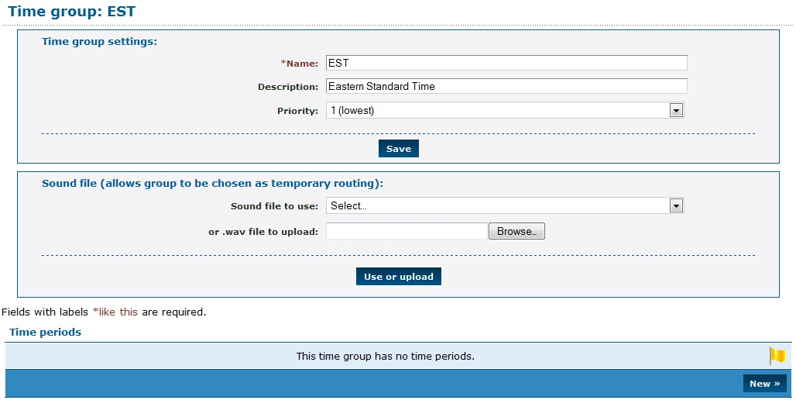
          - To make this group “selectable” in the IVR for temporary routing, upload a .wav file for the name of the group to be played to callers.
          - Set time routes for any numbers or feature codes as desired.

Add a Time Period
To add a new Time Period:
        - Log in to the Enswitch web interface.
          - Go to Features » Times and dates.
          - Select the time period to modify.
          - Scroll down to Time periods.
          - Click New.
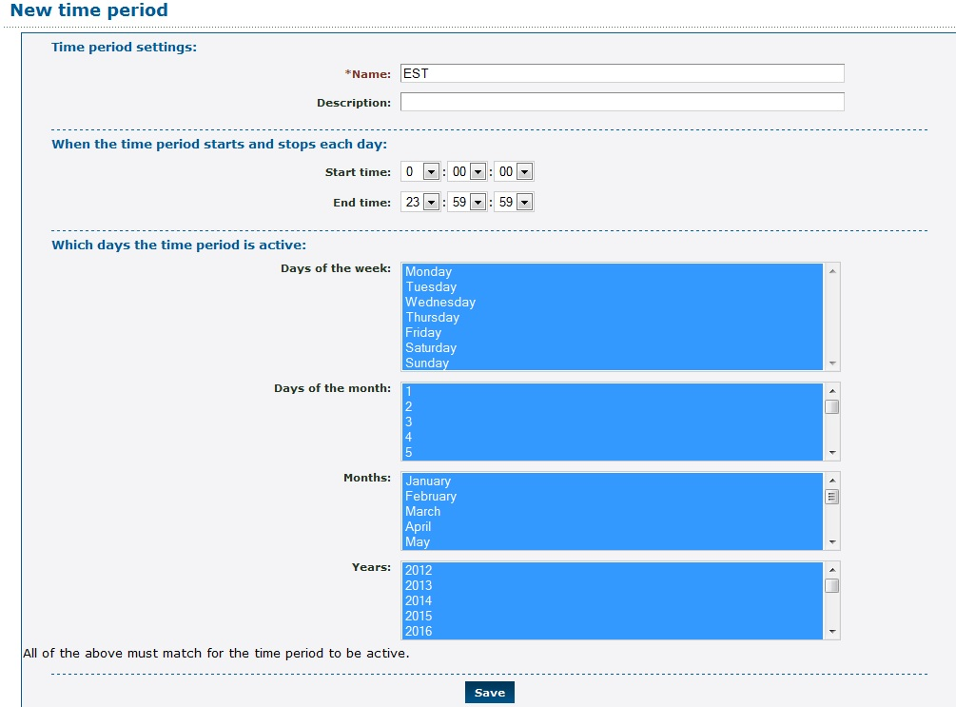
          - Enter the following: (fields marked with are required)
- Name: Unique name identifying this time period.
            - Description: Description of the time period. This appears on the menu of time periods.
            - Start time/End time: Start and stop time each day.
            - Days the period is active: All the options must match the date for the period to be considered active.
          - Click Save.
          - Repeat for any other time periods.

Virtual Telephones
Virtual telephones are useful in a hot desk environment. A set of virtual telephones contains physical telephones, one on each desk. Their telephone lines can have very simple settings and a restrictive class of service to prevent them from calling billable destinations. Each person who uses the hot desk environment can have a virtual telephone line with all their settings, speed dials, and class of service.
When a person walks up to a desk, they log in their virtual telephone on top of the physical telephone. At that point, any call to their virtual telephone causes the physical telephone to ring. When calls are made out from the physical telephone, they are made with the settings of the person's virtual telephone line. When the person leaves, they log out and the physical telephone reverts to its own settings.
Multiple virtual telephones can be logged on the same physical telephone. In this case, calls for any of the virtual telephones cause the physical telephone ring. Calls made from the physical telephone have the settings of the last virtual telephone to log in. When that virtual phone logs out, the settings revert to those of the physical telephone, even though other virtual telephones remain logged in. Re-logging in on one of the other virtual telephones causes its settings take effect.
To configure virtual telephones:
        - Log in to the Enswitch web interface.
          - Ensure that at least two telephone lines exist under Features » Telephone lines.
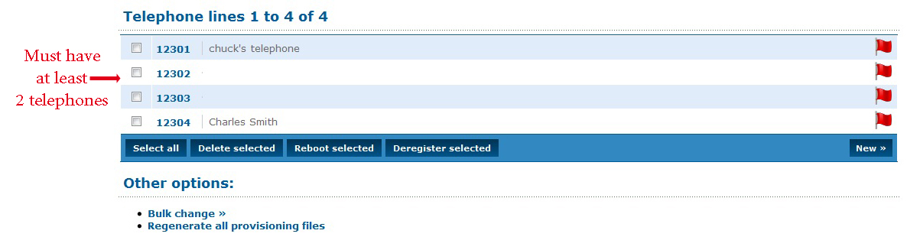
          - Set a feature code to point to the virtual telephone login feature.
          - Make telephone lines for all physical and virtual telephones.
          - Set a virtual telephone PIN for all virtual telephones.
          - Configure handsets with the physical telephone settings and register them to the system.
          - From a physical telephone, call the feature code.
          - Follow the prompts to enter a virtual telephone number and PIN.
          - To log out, call the feature code and again follow the prompts.

Web URLs
Enswitch can consult an external web URL for directions on how to route a call. Enswitch passes details of the call to the URL. The expected response contains the routing information. Any customer on the system can perform dynamic routing of calls without the expense and complexity of their own telephone system.

Call Flow
- The call is delivered to the feature, such as a number or feature code, that has “Ask web URL” set as its destination.
- Enswitch invokes the routing URL specified using HTTP POST, passing the form fields listed in 31.2, Input fields.
- The web server responds with a text document that includes the fields listed in 31.2, Output fields. Normally this document is dynamically generated using a CGI script or similar server side tools.
- Enswitch routes the call to the destination specified by the text document.
- When the web request takes more than the specified timeout (5 seconds by default), including time for DNS lookup, the web request is cancelled and the call is routed to the timeout destination.
- Routing is accomplished within a few seconds of these events when the web URL or the web server specified URLs are to be invoked on answer and on hangup. These URLs are invoked multiple times when there are multiple legs.

Fields
Input Fields
Enswitch passes the following fields in the POST to supply details of the call:

scustomer | The ID of the source customer. This is normally the same as the customer. This field is deprecated and might be removed in future.
stype | The source type. This is normally “external” for an external number, or “phone” for a local telephone.
snumber | The source number; calling number or telephone. If a telephone, it is the account rather than callerid.
ctype | The called type. This is normally blank, unless a call has been redirected.
cnumber | The called number, as presented to the system.
dcustomer | The ID of the destination customer. This is normally the same as the customer. This field is deprecated and may be removed in future.
dtype | The destination type that sent the call to the URL. For example, “number” or “code”.
dnumber | The destination number that sent the call to the URL, i.e. the number or feature code. For some dtypes such as IVR, this is the ID of the object in the database.
server | The hostname of the server invoking the URL.
callid | An identifier for the call. The combination of server and callid are different for every call. Legs of the same call have the same callid but can have different uniqueids, depending on how they are routed within the server.
uniqueid | An identifier for the call leg within the server at the telephony level.
state | The state of the call. URLs invoked at the start of the call is passed “ring” or “answer”. URLs at the end of the call with be passed “hangup”.
patternmenu_digits | If the call passed through a pattern menu that collected DTMF digits from the caller, the digits collected.
Fields Passed on Hang-up:

totaltime | How long the call ran for in seconds, including ringing.
talktime | How long the call ran for in seconds, excluding ringing. For calls which were not answered, this will be 0.
status | The status of the call. Normal values are “answer”, “busy”, “cancel”, “congestion”, or “noanswer”, though other values indicating routing errors are possible.
recording | The path to the recording file. If there was no recording, this will be an empty string.
Other fields might be added in future without warning.
Output Fields
The web server is expected to return a text document with content type “text/plain”. For the routing URL invoked at the start of the call, this should be one field per line as in the sample below. For the answer and hangup URLs, the text is ignored, so an empty document (apart from any HTTP headers your web server requires) should be sent.
Sample Document:
dtype: phone
dnumber: 1234567
answer_url: http://example.com/answer.cgi
hangup_url: http://example.com/hangup.cgi
Lines may be terminated by newline (“\n”) or carriage return followed by newline (“\r\n”). Don't forget to add any HTTP headers required by your web server such as “Content-Type: text/plain\r\n\r\n”. The fields to return are:

dtype | Destination type to send the call to.
dnumber | Destination number to send the call to.
answer_url | A URL to invoke after the call has been answered. The URL is invoked once for each leg. This field is optional, and overrides the setting specified in the web URL within Enswitch.
hangup_url | A URL to invoke after the call has hung up. The URL is invoked once for each leg. This field is optional, and overrides the setting specified in the web URL within Enswitch.

Create and Modify Web URL
To add a new web URL:
        - Log in to the Enswitch web interface.
          - Go to Features » Web URLs.
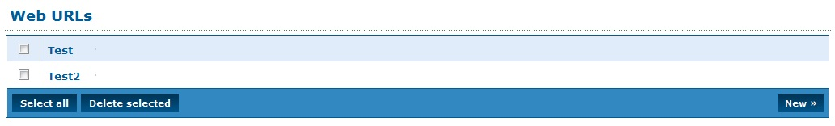
          - Click New.
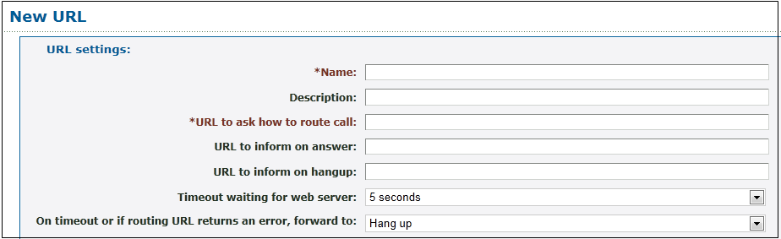
          - Enter the following: (fields marked with are required)
- Name: Unique name designating this group of URLs
            - Description: Description of this entry. This appears on the Web URLs menu page to the right of the name.
- URL to ask how to route call: HTTP URL that Enswitch asks to where to route the call
            - URL to inform on answer: HTTP URL that Enswitch informs when the call has been answered
            - URL to inform on hangup: HTTP URL that Enswitch informs when the call has been hung up
            - Timeout waiting for web server: How long to wait for the web server before timing out
            - On timeout or if routing URL returns an error, forward to: Enter the information to route the call when timeout occurs or when the web server returns an error.
          - Click Save.
          - Set a number or feature code to route to the web URL.
To edit an existing web URL:
        - Click the name of the web URL.
          - Modify the web URL parameters.
          - Click Save.
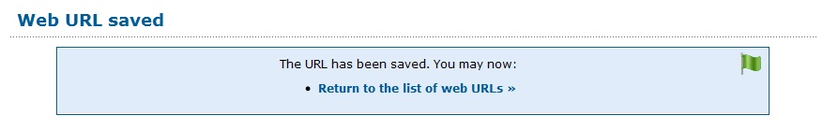
          - Click Return to the list of web URLs.

Workflows

Allowing Numbers to be Toggled Separately
You can control the routing of a selected phone line from a handset or from an outside line by creating a feature code with the necessary properties. A typical application is changing the routing of a telephone line so that the telephone rings at the receptionist position during the day and connects immediately with voice mail at night.

Overview
By defining a feature code, combined with built-in recordings that tell the user what to do, you can create a setup that allows users to change the routing of a selected incoming line.
The flow sequence consists of two major steps:
        - Associate the Number Menu Feature with a Code.
          - Toggle the Destination of a Phone Line Using the Code.

Associate the Number Menu Feature with a Code
To define a feature code associated with a number menu:
        - Go to Features » Feature Codes.
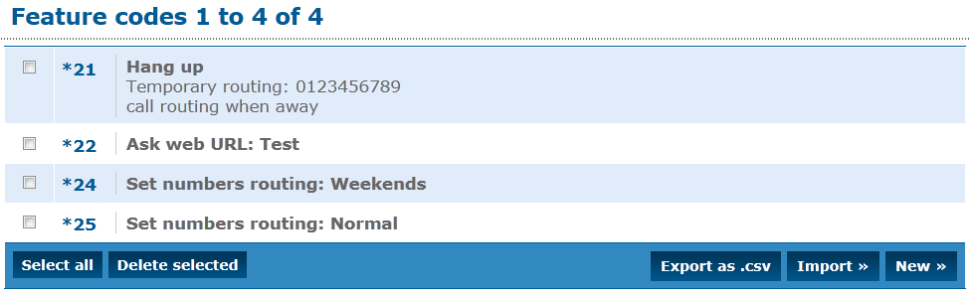
          - Click New. Enter a feature code (for example, *23).
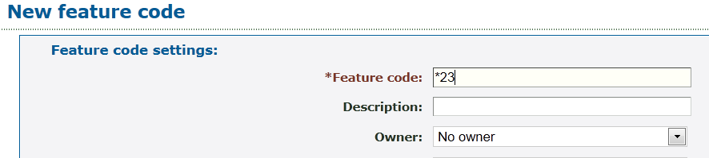
          - Scroll to the Default destination section, select Feature and, at the Feature drop-down menu, select Number menu.
          - Enter a numeric PIN (usually four digits).
          - Click Save at the bottom of the form. The new feature is saved.

Toggle the Destination of a Phone Line Using the Code
A user who knows the PIN associated with the Number menu can toggle the destination of an incoming phone line. In this example, it is the receptionist’s phone.
        - The user keys *23 on a local handset, or the user calls in from the outside and enters *23 – essentially a “secret code” not mentioned on the incoming IVR menu. The system plays the following message, associated with the number menu feature:
“Please enter the number you wish to work with followed by the pound sign/hash.”
          - The user enters the phone number that rings at the receptionist’s desk. The system plays the following message:
“Please enter the PIN followed by the pound sign/hash.”
          - The user enters the PIN associated with the *23 feature, followed by #. The system plays the following message:
"For normal time of day routing, press one. To enter a number, press zero. To return, press star."
          - The user either enters 1 to route the receptionist’s line to its normal place – the receptionist’s desk – or enters 0, followed by the voice mail extension, followed by #. The system routes any calls received on the phone number entered in step 2 according to the selection.

Allowing Users to Toggle the Routing of Numbers Using Their Handsets
This flow shows how a user who knows the appropriate PINs can change the destination of incoming calls to a group of phone numbers. Use this feature to route all calls to their normal destination during the week and to an alternate location (for example, voice mail) on the weekend.

Overview
This flow sets up a pair of feature codes to toggle the routing of a group of phone lines.
The flow sequence consists of four major steps:
        - Associate the Set Numbers Routing: Weekends Feature With a Code.
          - Add a Time Route to All Numbers to be Routed with this Feature.
          - Associate the Set Numbers Routing: Normal Feature with a Code.
          - Use the Codes to Change the Routing of the Selected Phone Lines.

Associate the Set Numbers Routing: Weekends Feature With a Code
        - Go to Features » Feature Codes.
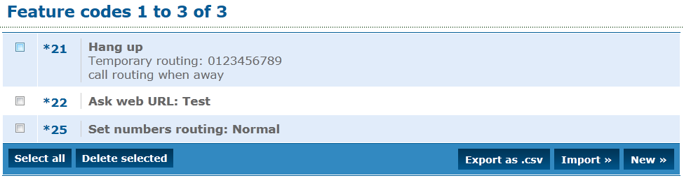
          - Click New. Enter a feature code (for example, *24).
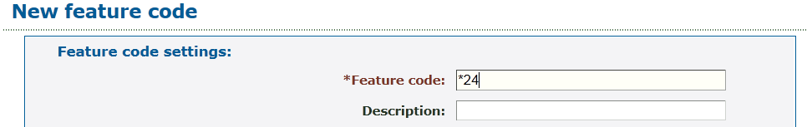
          - Scroll to the Default destination section, select Set routing to time group, select Weekends on drop-down menu.
          - Enter a numeric PIN (usually four digits) and click Save.

Add a Time Route to All Numbers to be Routed with this Feature
        - From the Feature menu, select Numbers and select one of the numbers to be routed.
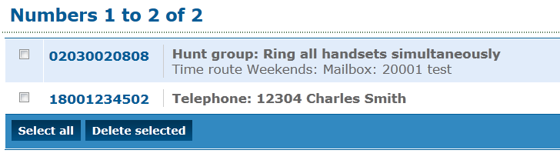
          - At the bottom of the Numbers form, under Time routes, click Add a time route ».
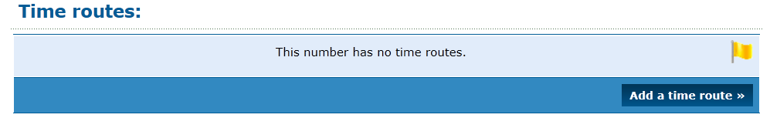
          - Under Time group select Weekends.
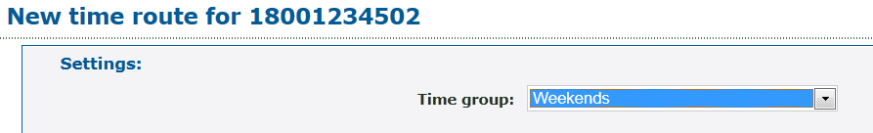
          - Under Calls to this group forward to select Voicemail mailbox and enter the voicemail extension.
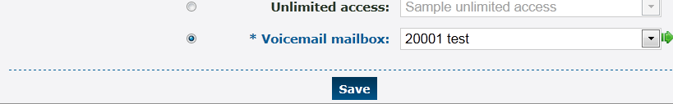
          - Click Save.
          - Repeat steps 1 to 5 for all numbers to be forwarded to voicemail on the weekend.

Associate the Set Numbers Routing: Normal Feature with a Code
        - Go to Features » Feature Codes.
          - Click New. Enter a feature code (for example, *25).
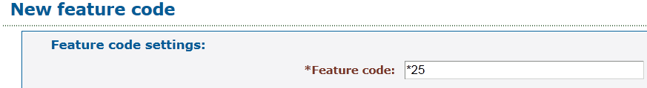
          - Scroll to the Default destination section, select Set routing to normal routing on the drop-down menu.
          - Enter a numeric PIN (usually four digits) and click Save.

Use the Codes to Change the Routing of the Selected Phone Lines
A user who knows the PINs associated with the *24 and *25 codes can change the routing of the selected phone numbers from normal routing to weekend routing a vice versa.
        - The user keys *24 or *25 on a local handset, or the user calls in from the outside and enters*24 or *25 – essentially a “secret code” not mentioned on the incoming IVR menu. The system plays the following message:
“Please enter the PIN followed by the pound sign/hash.”
          - After the user enters the PIN, the system changes either to weekend routing or normal routing, depending on which code the user entered.

Connecting an Incoming Call to a Queue via Tiered IVR Menus
In a common usage of telephone systems, calls are directed to hierarchical voice menus where the caller selects numeric options that direct the call to the proper destination extension. For example, a first level menu selects between departments, and the second-level menus point to the people in the selected department. This workflow shows how to create the elements necessary to connect from an incoming call to a destination extension via tiered IVR menus and a queue of calls waiting to be answered.

Overview
In a real-world example, an incoming telephone number connects to a primary IVR menu. The options of this menu would point to multiple secondary level IVR menus, and each possible response could connect to a queue. This flow demonstrates a single thread example, with a primary IVR menu, one secondary IVR menu, and one queue. The workflow builds the call flow from back to front, starting with the queue.
The flow sequence consists of four major steps:
        - Create and Configure a Queue.
          - Create and Configure a Secondary IVR Menu.
          - Create and Configure a Primary IVR Menu.
          - Select a Phone Number and Connect It to the Primary IVR Menu.

Create and Configure a Queue
To create and configure a queue:
        - Go to Features » Queues to display the list of existing queues.
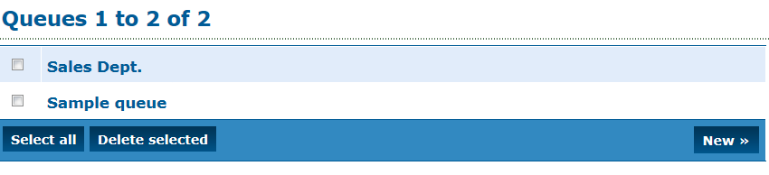
          - Click New to display the queue form.
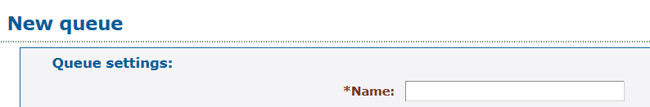
          - Enter a queue name (for example “Marketing Department”).
          - Scroll down to When exiting queue, forward to: and select Mailbox and enter the mailbox number.
          - Click Save. The Queue Saved notice is displayed.
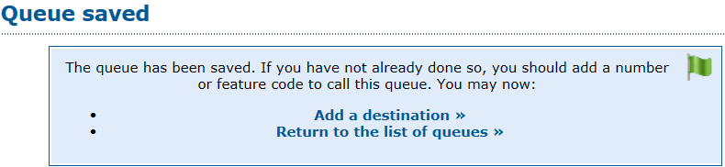
          - Click Add a destination to display the New destination form.
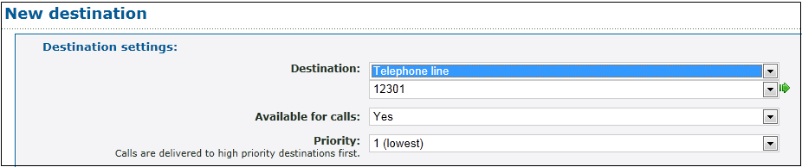
          - Select the Telephone Line option. Select a number within the available list as the destination.
          - Click Save.
          - Click Add another destination to redisplay the New destination form.
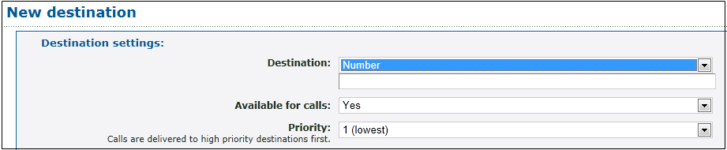
          - Select Number and enter an external phone number as a possible destination of calls on this queue.
          - Click Save.
          - Go to Features » Queues. Your newly created queue should be in the list. Click the queue name. All of the settings for the queue are displayed for you to review. You can modify any of the settings as necessary.

Create and Configure a Secondary IVR Menu
To create and configure a secondary IVR:
        - Go to Features » IVR Menu to display the list of defined IVR menus.
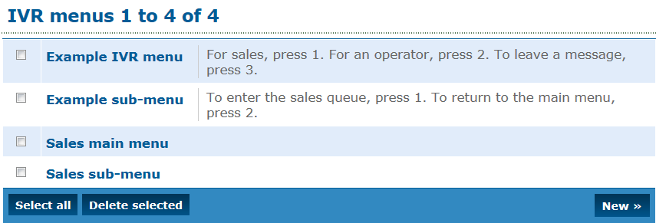
          - Click New to display the New IVR menu form.
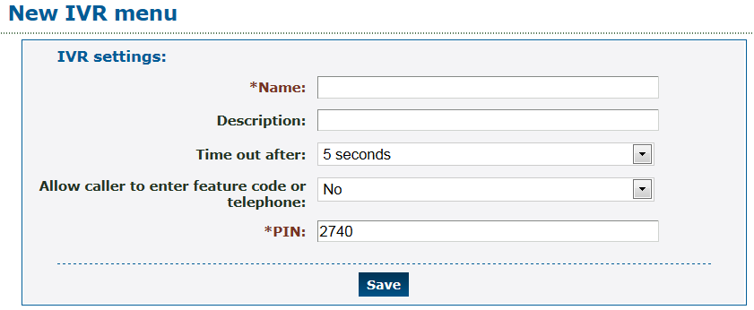
          - Enter a name for the IVR menu (for example, Marketing sub-menu).
          - In the Destinations section, from the "1" drop-down menu, select the IVR menu option and select the secondary menu you created previously.
          - Click Save.

Create and Configure a Primary IVR Menu
To create a primary IVR menu, start the same way that you created the secondary menu:
        - Go to Features » IVR menus.
          - Click New.
          - Name the primary menu (for example, Marketing primary menu) and click Save.
          - In the Destinations section, from the "1" drop-down menu, select the IVR menu option and select the primary menu you created previously.
          - Click Save.

Select a Phone Number and Connect It to the Primary IVR Menu
To associate a phone number to the primary IVR menu:
        - Go to Features » Numbers to display the Numbers menu.
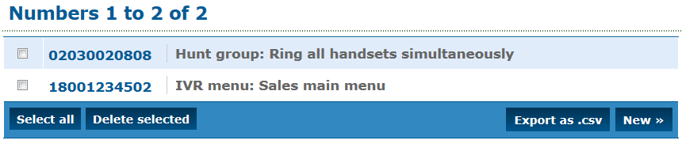
          - Click New to display a blank number form.
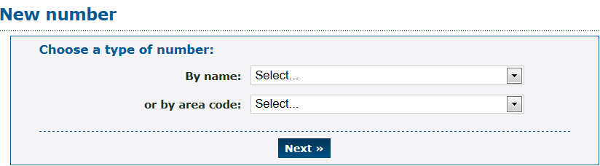
          - Select a valid number. For example, from the By Name drop-down menu, select North America Toll Free: 1800. Click Next to display the Choose Number form.
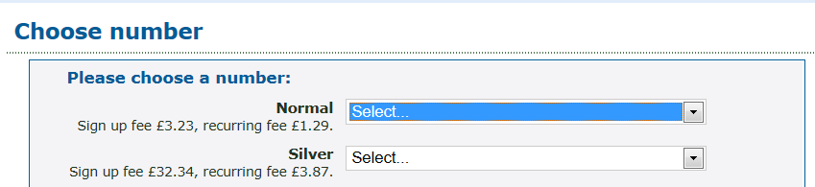
          - On the Normal drop-down menu select one of the available numbers. Click Next to display the Number Settings form.
          - On the Default destination drop-down menu, select IVR menu. Select the primary menu (Marketing primary menu) you just defined.
You need additional settings to complete configuration of the items created in this workflow. For example, the IVR menus each need a recording to play to the caller that says which number to press for each possible option. See the Enswitch Administrator's Guide for detailed feature descriptions.

Connecting an Incoming Call to a Hunt Group that Terminates in a Mailbox via Tiered IVR Menus
When an incoming call is directed to a hunt group, all of the extensions in the hunt group ring until one of them answers. If none of them answers after a period of time, the call can be directed to a voice mailbox where the caller can leave a message. This flow shows how to create the elements necessary to connect from an incoming call to a hunt group via voice menus and to default to a voice mailbox when there is no answer.

Overview
In the example described by this flow, an incoming telephone number is directed to an IVR menu. After making a selection on a primary and a secondary IVR menu, the call is directed to a hunt group. The hunt group targets a voice mailbox when there is no answer on any of the destination phone lines. The workflow builds the call flow from back to front, starting with the voice mailbox.
The flow sequence consists of five major steps:
        - Define and Configure the Destination Mailbox.
          - Create and Configure a Hunt Group.
          - Create a Tiered IVR.
          - Direct a Secondary IVR Option to the Hunt Group.
          - Select a Phone Number and Direct it to the Primary IVR Menu.

Define and Configure the Destination Mailbox
To create a mailbox:
        - Go to Features » Mailboxes and click New to display the mailbox definition form.
          - Enter the extension associated with the mailbox as the mailbox name.
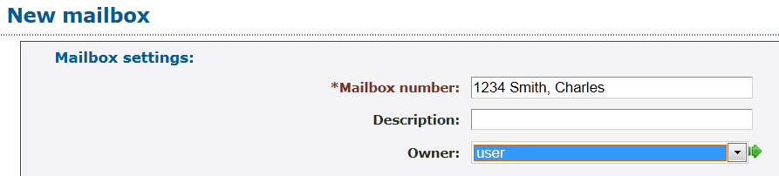
          - Select the extension owner from the Owner drop-down menu. In an actual installation, the owner’s name appears in the list.
          - Enter a PIN for the mailbox; re-enter it in the PIN Repeat field.
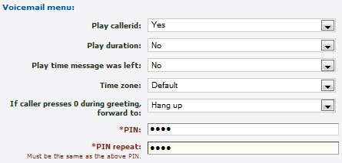
          - Click Save.

Create and Configure a Hunt Group
Hunt groups can have from one to ten destination levels and a default level. All destinations in level 1 are rung simultaneously. After a defined interval, all destinations in level 2 are rung simultaneously, and so on to level 10. If there is no answer in any of the defined levels, the call is transferred to the default destination.
        - Go to Features » Hunt groups.
          - Click New to display the Hunt Group form.
          - Give the hunt group a name and click Save.
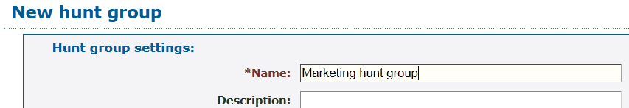
          - Click Set the default destination to display the Default destination form.
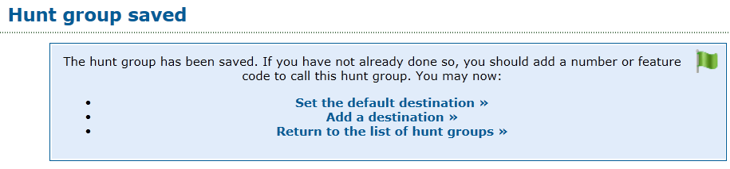
          - Select Mailbox and from the drop-down menu, select the mailbox created in the previous step.
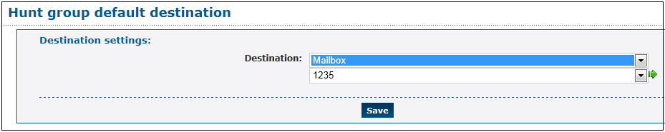
          - Click Save. Now click Add a destination to display the New destination form. With this form, you can define the phone number in each level of the hunt group.
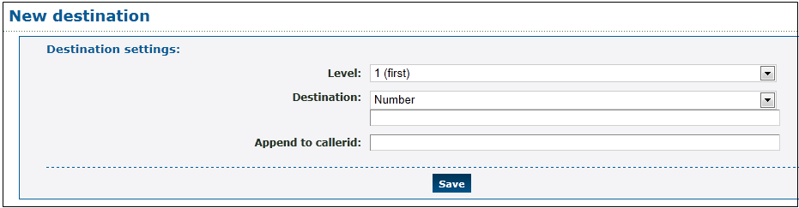
          - Select Telephone Line in the Destination section and select the telephone number.
          - Click Save. You can click Add a destination to add additional numbers and additional levels.

Create a Tiered IVR
See Create and Configure a Secondary IVR Menu (32.3.3) and Create and Configure a Primary IVR Menu (32.3.4).

Direct a Secondary IVR Option to the Hunt Group
To connect an IVR destination to a hunt group:
        - Go to Features » IVR menus and click the sub-menu just created to display the IVR form.
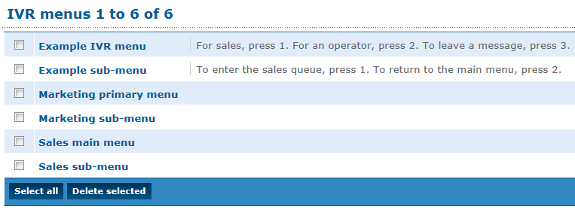
          - In the Destinations section, from the "2" drop-down menu, select Hunt group, select the hunt group defined in the previous section, and click Save.
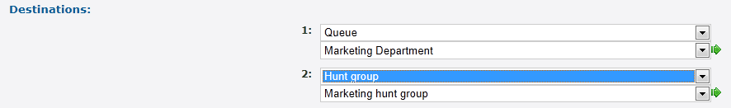

Select a Phone Number and Direct it to the Primary IVR Menu
See Select a Phone Number and Connect It to the Primary IVR Menu (32.3.5).

Connecting an Incoming Call to a Telephone Line, Then to a Hunt Group That Terminates in a Mailbox
When an incoming telephone call rings an internal extension, it may be desirable to:
- Connect an incoming call to a hunt group when there is no answer on the extension, and then
- Connect it to a voice mailbox if there is no answer on any of the numbers in the hunt group.

Overview
This flow shows how to define a mailbox, how to define a hunt group and point it to the mailbox, and how to redirect a telephone number to a hunt group when there is no answer on the primary extension.
The flow consists of three major steps:
        - Define and Configure the Destination Mailbox.
          - Create and Configure a Hunt Group.
          - Direct an Incoming Telephone Line to the Hunt Group.

Define and Configure the Destination Mailbox
See Define and Configure the Destination Mailbox (32.4.2).

Create and Configure a Hunt Group
See Create and Configure a Hunt Group (32.4.3).

Direct an Incoming Telephone Line to the Hunt Group
To direct an incoming call to a hunt group when there is no answer on the primary extension:
        - Go to Features » Numbers and click one of the defined numbers to display the number configuration form.
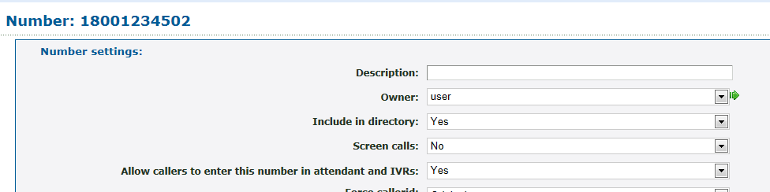
          - In the Default destination section, select Telephone line and select the desired extension on the drop-down menu.
          - Click Save.
          - Go to Features » Telephone lines and click on the telephone line used as the target extension in the previous step.
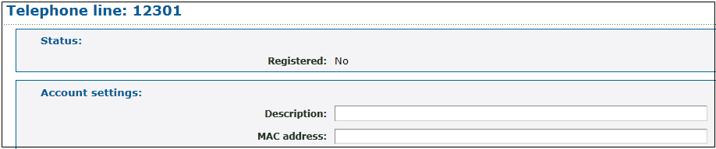
          - In the telephone line form, scroll down to the On no answer section. Select Hunt group and choose the hunt group defined earlier.
          - Click Save.
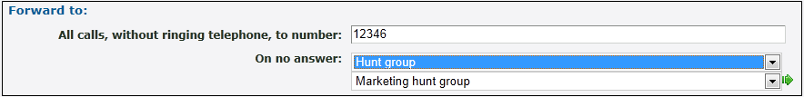

Enswitch per-Telephone Provision Setting
Provisioning an IP phone is straightforward. To do it, you will need information from the Enswitch system owner.

Overview
Provisioning an IP phone requires a phone number for the phone, the MAC address of the phone, the Enswitch web URL, and provisioning data in a format appropriate to the phone model. The system owner will give you the format of the provisioning data.
The provisioning flow consists of two major steps:
        - Configure the Telephone with Handset Information.
          - Configure the Handset with the Enswitch URL.

Configure the Telephone with Handset Information
        - Go to Features » Telephone lines and click the telephone line associated with the new phone.
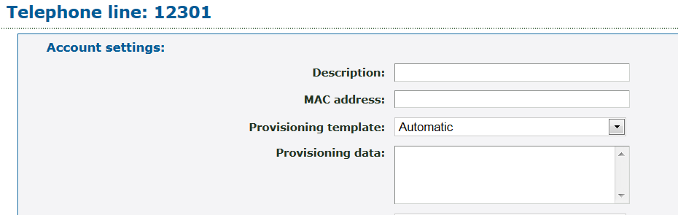
          - Enter the MAC address of the phone (you can find it on a sticker on the bottom of the phone in the format 00:00:00:00:00:00 – 12 hexadecimal digits, possibly without the “:” separators).
          - Enter the provisioning data for the phone. The system owner will provide you with the format of this information for your phone model.
          - Click Save.

Configure the Handset with the Enswitch URL
        - Plug in the handset to a switch connecting it to the Enswitch system.
          - Configure the handset according to the manufacturer’s instructions and those of the system owner. As part of this process, enter the URL of the Enswitch interface in the handset itself. The handset instructions should show how to do this.
When the telephone boots, it will go to Enswitch to retrieve its configuration settings from the telephone number settings.

Integrating with Queue Statistics
Collecting queue statistics is an optional feature. The following flow applies only to installations with enabled queue statistics collection.

Overview
Queue statistics are a detailed file of events that occur on a selected queue when callers wait for someone to answer. With analysis, an administrator can learn when callers complete calls or hang up, when the traffic is heaviest, and so on.
The flow consists of two steps:
        - Configure Queue Statistics.
          - Export Queue Statistics.

Configure Queue Statistics
To configure statistics collection for a selected queue:
        - Go to Features » Queues and select the desired queue.
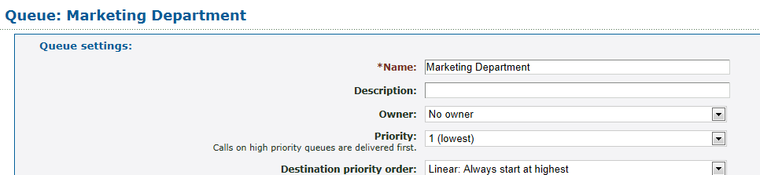
          - Scroll down to the bottom of the displayed form to Other options for this queue: and click Queue statistics.
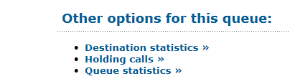
          - On the statistics form, set the start date and end date for statistics collection and then click Update. You can return to this form periodically and see the displayed statistics for this queue.
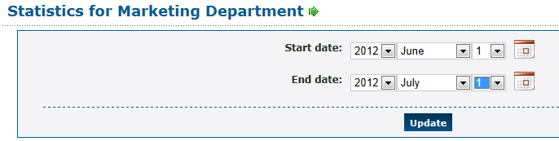

Export Queue Statistics
To export a file of collected statistics for a queue:
        - Go to Features » Queues and select the desired queue.
          - Scroll down to the bottom of the displayed form to Other options for this queue: and click Export Events. (This option is available only if there were events collected).
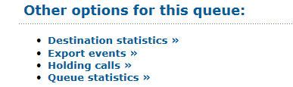
          - Set the start and end date for the period that you want to analyze and click Export. A file named queue_log is created containing statistics records for the defined period. You can use a spreadsheet or other tools to learn more about the queue activity.

RDNIS Voicemail Configuration
An external service provider, such as a cell phone company, can use Enswitch as its voicemail service. The service provider forwards the call to Enswitch using the Redirected Dialed Number Information Service (RDNIS) protocol.

Overview
When an external service provider uses Enswitch for voicemail services, the service provider is assigned a telephone number, and all forwarded calls go to this number. On connecting with the telephone number, the service provider sends a string of numbers in RDNIS format that identify the target of the phone call. The Enswitch customer needs to define an Enswitch voice mailbox for each defined target telephone number. The mailbox number is based on the RDNIS format used, so the Enswitch customer needs to get the exact format from the external service provider. This flow shows the steps required to set up a RDNIS voicemail scheme.
The flow consists of two steps:
        - Create a Mailbox for an RDNIS-Formatted Forwarded Call.
          - Assign a Number that Connects All Calls to Voicemail.

Create a Mailbox for an RDNIS-Formatted Forwarded Call
        - Go to Features » Mailboxes and click New.
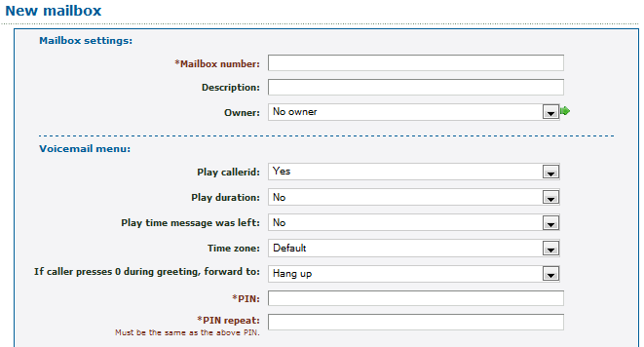
          - Enter the phone number in the format sent by the external service provider. For example, this could be a full phone number, such as 3015551212, or it may include other leading or trailing digits, according to the service provider format.
          - Enter a PIN/ PIN repeat.
          - Click Save.

Assign a Number that Connects All Calls to Voicemail
        - Go to Features » Numbers and click the number called by the service provider to forward to voicemail.
          - In the Default destination section of the form, select Feature and select Voicemail mailbox of RDNIS. Click Save.
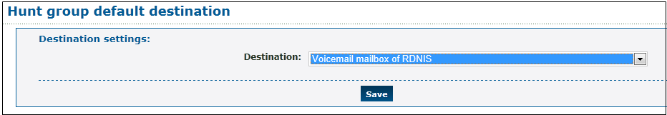

Creating a Hosted Recording Service
The system can record calls made to and from the system. You can select which calls to record using several criteria and also selectively list recording for future playback.

Overview
Call recording is built around call record groups that define which calls to record and when. Once a record group is defined, each telephone line or number to be recorded must be associated with the record group.
The flow consists of four steps:

        - Adding a New Group.
          - Setting Recording Parameters for the new record group.
          - Associate the Record Group with a Telephone Line.
          - Reviewing Recordings for the record group.

Adding a New Group
To add a new record group:
        - Go to Features » Call Recording.
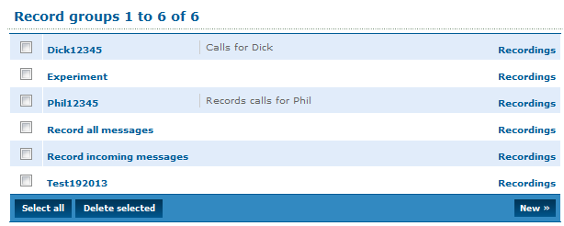
          - Click New » to open the New Record Group form.
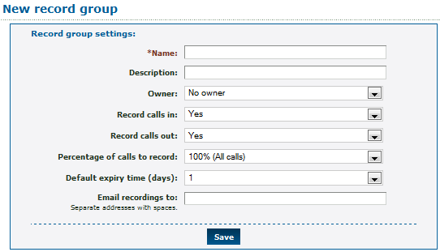
          - Enter a name for the new record group and click Save.
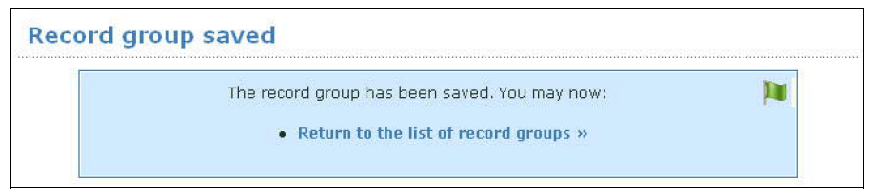

Setting Recording Parameters
To set recording parameters for the new record group:
        - From the Record Group Saved form, click Return to the List of Record Groups.
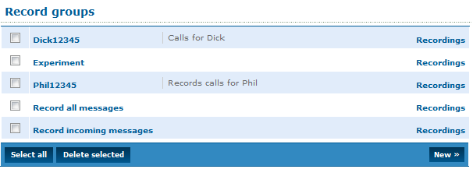
          - From the Record Groups list, click the new record group you created to open the Record groups form.
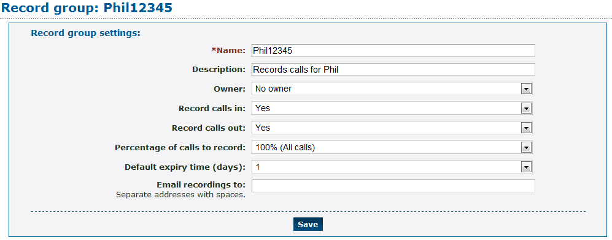
          - Enter the configuration settings for the new record group:
            - Record calls inL Yes enables recording; No disables recording; the default is Yes.
            - Record calls out: Yes enables recording; No disables recording; the default is Yes.
            - Percentage of calls to record: Select a percentage of calls to be recorded from the pull-down list of options. The default is 100%.
            - Default expiry time (days): Expiry time in days for storing recorded calls. The default is 1.
            - Email recordings to: One or more email addresses to send recordings to at the end of each call.
          - Click Save.

Associate the Record Group with a Telephone Line
Telephone lines, numbers, page groups, queues, and remote access accounts can be associated with a record group. This step shows how to associate a telephone line with a record group.
        - Go to Features » Telephone lines to display the list of telephone lines.
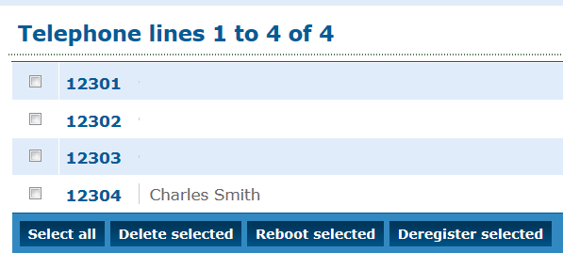
          - Click on the desired telephone line to display the form for that line.
          - Scroll down to the Line Settings section and select the desired group from the Record group drop-down menu.
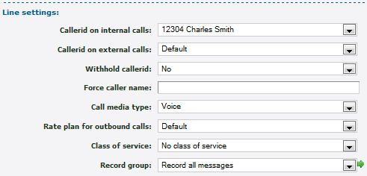
          - Click Save.

Reviewing Recordings
Reviewing recordings for a record group:
        - Go to Features » Call Recording, then click Recordings for the desired record group.
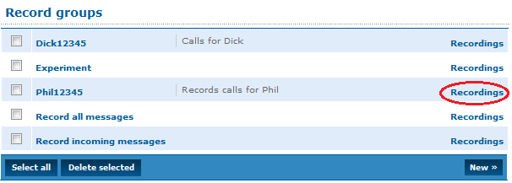
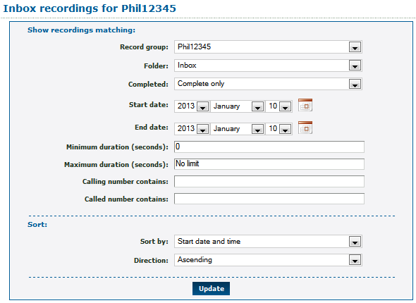
          - Use the various optional filter and sort choices to review a selection of the available recordings.
            - Folder: select the directory where the recordings are stored; the default is Inbox.
            - Completed: Status of call being recorded; the options are Complete only, In Progress only, or Both Complete and In Progress.
            - Start Date/End Date: Date range for filter.
            - Minimum/Maximum Duration: Duration for recording in seconds.
            - Calling Number Contains: Filter for calling number.
            - Called Number Contains: Filter for called number.
            - Sort by: Sort mechanism for results returned by query; the options are Start Date and Time, Expiry Date and Time, Duration, Caller, and Called.
            - Direction: Ascending or descending.
          - At any time, click Update to display a list of recordings.

- Telephone Models
This list of telephone models is incomplete, and some entries may be out of date. Any updates are welcome. All information on this page is informal, and no guarantees are offered. As always, it's vital to fully test all functionality before offering it to your customers.
- "Working" means that the basic functions of the telephone have been reported as working.
- "Fully working" means that all or almost all relevant functions of the telephone have been reported as working. Integrics has not verified these for all telephones.
Hardware SIP telephones
Aastra 51i, 53i, 55i, 57i, and 67xx
            - Fully working.
            - Busy lamps are working.
            - Automatic provisioning is working.
            - Auto-answer for page groups is working.
Cisco 7912, 7940, and 7960
            - Working using SIP image.
            - Set the following:
messages_uri: "+1"
            - Set the following if behind NAT:
nat_enable: 1
nat_received_processing: 1
nat_address: ""
            - May also require port forwards on some NAT devices.
Cisco SPA500 series
            - Working.
            - Some customers report that when doing a blind transfer, the handset reports that the transfer failed even though it succeeded. Others are unaffected.
Elmeg 290
            - See the Snom 190, on which this telephone is based.
Grandstream Budgetone 101 and 102
            - Working.
            - Turn on NAT settings if behind a NAT device.
            - Automatic provisioning is working.
Grandstream GXP2000
            - Working.
            - Busy lamps are working. This requires the latest Grandstream firmware.
Polycom SoundPoint IP range and VVX 1500
            - Working if not behind NAT.
            - The level of success when used behind NAT varies. Firmware 3.2.1 and later seem to work reliably. Older firmware seems to depend on the exact NAT device used.
            - Fortigate routers are reported to fix NAT problems with older firmware versions.
            - Busy lamps are working. Some Polycom firmware versions may require that you set voIpProt.SIP.dialog.strictVersionValidation=”0”.
            - Automatic provisioning is working.
            - Remote reboot from the Enswitch web interface is working.
            - VVX 1500 video is working.
Siemens C460 IP Gigaset
            - Working.
Sipura SPA 941, 942, 1001, 2002, and 3000
            - Working.
Snom 190, 320, 360, 370, 820, and 870
            - Fully working.
            - Busy lamps are working.
            - Automatic provisioning is working.
            - Auto-answer for page groups is working.
UTS F3000
            - Working.
            - SIP messaging is working. This requires this feature to be enabled in Enswitch.
Yealink T26P, T28P, and VP-2009
            - Working for audio.
            - Working for video.
Analog telephone adapters (ATAs)
Audiocodes MP-124
            - Working.
DrayTek Vigor2800
            - Working.
Grandstream Handytone 286, 287, and 386
            - Working.
Linksys PAP2
            - Reports indicate occasional spurious DTMF key-presses on its analog side. Apart from that, working.
Motorola VT1000
            - Working.
PBXs
Asterisk
            - Fully working.
            - Make a telephone in Enswitch, then set the following in Asterisk's sip.conf:
username = <telephone line>
fromuser = <telephone line, unless original callerid is set>
secret = <telephone password>
insecure = port,invite
context = <context for incoming calls>
            - Add a context in extensions.conf for outgoing calls.
Cisco Call Manager and Call Manager Express
            - Working.
            - Requires a remote access account for outbound calls due to lack of SIP authentication support.
Enswitch
            - Fully working.
            - Please see Asterisk, which Enswitch uses for connections to carriers.
            - The context for incoming calls is normally "from-external".
            - Make a peer for the outgoing context.
NEC XN120
            - Working.
Routers and gateways
Cisco 53xx and 54xx
            - Working.
            - Requires a remote access account for outbound calls due to lack of authentication support.
Multitech ISDN2e gateway
            - Working.
Nextone
            - Working.
Teles SS7 gateway
            - Working.
Session border controllers
Sansay SPX
            - Working.
            - Known problem where call drops when put on hold twice. This is due to a Sansay bug. It can be worked around on Enswitch.
Softphones
3CX for Android
            - Working.
Acrobits for Android
            - Working.
Bria
            - Working for audio.
            - Working for video.
Bria Android and iPhone/iPad editions
            - Working.
CSipSimple for Android
            - Working.
Eyebeam
            - Working for audio.
            - Video is untested.
Sipdroid for Android
            - Working.
SJ Phone
            - Working.
Voice Operator Panel
            - Latest version is working.
            - Older versions had problems with music on hold.
X-Lite
            - Working.
Zoiper
            - Working.
            - Requires DTMF to be set to SIP INFO.
Client side NAT routers
Cisco 8xx
            - Fully working.
D-Link DIR-655
            - Fully working.
D-Link (other models)
            - Not working. Inbound calls are sometimes blocked.
Edgemarc 200 and 4500 series
            - Not working in SIP ALG mode.
Fortigate 30B, 50B, 60B, 80CM, and 110C
            - Fully working, including SIP AGL.
            - Reported to support all versions of Polycom firmware behind NAT.
            - The following is recommended:
config system global
set tos-base-priority medium
end
            - Set the SIP policy to "high".
Linksys
            - Working with a single handset.
            - Mixed reports with multiple handsets behind one router, with occasional reports of inbound calls being delivered to the wrong handset.
Mikrotik RB450
            - Fully working on firmware 3.13.
Netgear
            - Not working. Inbound calls are sometimes blocked.
Smoothwall Express
            - Fully working.

